Regaining Trust in AI:
How Trust Erodes and Recovers After Temporary and Permanent Forecasting Errors
Dae Keun Parkª, Woojin Kim^{b}, and Hyo Young Kim^{c}*
ª Department of AI Healthcare Convergence, Cha University, Pocheon-si, Gyeonggi-do, 11160, Republic of Korea (Email: dkpark@cha.ac.kr)
^{b} Korea University Business School, Korea University, Seoul, 02841, Republic of Korea (Email: kimwj2990@korea.ac.kr)
^{c} Department of Artificial Intelligence, Tech University of Korea (TU Korea), Siheung-si, Gyeonggi-do, 15073, Republic of Korea (Email: hyoyoung@tukorea.ac.kr)
* Corresponding Author: Hyo Young Kim (hyoyoung@tukorea.ac.kr)

Abstract
How do people update their reliance on advice following forecasting errors, and does this process differ depending on who, or what, provides the advice? Study 1 examines longitudinal changes in advice reliance under algorithmic and human advisory input, focusing on the temporal structure of forecasting errors. In a controlled experiment (N = 120), participants completed sequential forecasts while receiving advice labeled as coming from either an AI system or a human expert. We introduced an additive outlier (temporary disruption) or a level shift (persistent disruption) and measured behavioral reliance using adjusted Weight of Advice (WOA_adj). The implemented LS profile produced a larger and more persistent reduction in WOA_adj than the implemented AO profile. Differences between AI and human advisor labels were numerically present but were not statistically distinguishable from zero. Recovery-model estimates were consistent with an incomplete return toward pre-shock reliance, but the LS-specific recovery interaction was sensitive to estimator and breakpoint choice. These findings highlight the relevance of shock-profile structure to advice reliance in this controlled setting, while not establishing that advisor identity is irrelevant or that persistence alone caused the contrast. Study 2 (N = 247) prospectively tested the same contrasts with preregistered breakpoints in an eight-cell design that crossed advisor label with one AO profile and three LS persistence profiles (theta = .70, .83, .88) under a common noise realization, and added pre- and post-feedback stated-trust measures. The post-shock reduction in WOA_adj replicated (b = -.036, p < .001), the LS profile again produced larger erosion than AO (LS x erosion b = -.053, p = .021), and advisor-label interactions were again not distinguishable from zero. The three LS persistence profiles did not order behavioral reliance monotonically, and stated trust returned to or above baseline after corrected advice began while behavioral reliance remained below baseline. We discuss implications for advice-taking, algorithm aversion, and dynamic human-AI interaction.
Keywords: Algorithm aversion, Trust recovery, Advice-taking, Structural shocks, Human–AI interaction, Weight of Advice, Behavioral judgment, Dynamic trust

- Introduction
People routinely rely on advisors, both human experts and automated algorithms, when making judgments under uncertainty (Bonaccio & Dalal, 2006; Prahl & Van Swol, 2017). A central question in behavioral decision research concerns how this reliance is calibrated in response to advisor errors: when an advisor fails, how much do people discount its future recommendations, and can that trust be rebuilt? Research on algorithm aversion has documented a robust asymmetry: people tend to penalize algorithmic errors more harshly than equivalent human errors, often abandoning an algorithm entirely after observing even a single mistake (Dietvorst, Simmons, & Massey, 2015). This phenomenon has been attributed to the "perfection schema", the expectation that algorithms, unlike humans, should not err (Dietvorst & Bharti, 2020; Madhavan & Wiegmann, 2007; Burton et al., 2020).
Yet most existing research treats trust as a largely static outcome, capturing its level at a single point following an error rather than tracking how it evolves over time. This is a consequential gap. In many real-world judgment settings, advisors eventually correct their predictions after an initial failure. Whether people recognize and respond to such corrections, and whether the resulting trust recovery differs across advisor types, remains poorly understood. Moreover, prior work has focused predominantly on whether trust erodes, rather than on the conditions that govern its trajectory once errors have occurred and been addressed.
A second underexplored dimension is the nature of the error itself. Not all forecasting failures are equivalent. In time-series contexts, errors may stem from temporary disruptions, such as additive outliers that produce a sudden but transient deviation, or from permanent structural changes, such as level shifts that alter the underlying data-generating process (Tsay, 1988; Chen & Liu, 1993). These two error types differ not only in their statistical properties but in their psychological implications: temporary errors may be discounted as isolated anomalies, while permanent shifts generate sustained disconfirmation of an advisor's reliability. How people respond to these fundamentally different error structures, and how their judgment updating unfolds across the full arc of erosion and recovery, has received little systematic attention.
Study 1 tests whether advisor identity (AI vs. Human Expert) and the implemented shock profile (AO vs. LS) are associated with the erosion and recovery of behavioral reliance within one controlled time-series realization. Participants made sequential forecasts with advice labeled as coming from either an AI system or a human expert. The study used a 2 (Advisor Type: AI vs. Human Expert) x 2 (Shock Profile: AO vs. LS) between-subjects design and tracked behavioral reliance using WOA_adj across 30 prediction rounds. This design describes advice-reliance trajectories before and after the implemented shock and after the forecasting rule began incorporating the specified correction.
Study 2 prospectively extends this test while preserving the same ARIMA(0,1,1) mechanism and realized innovation sequence: it varies only the LS moving-average parameter (theta = .70, .83, and .88) to examine whether prespecified differences in forecast-error persistence shape the erosion and recovery of behavioral reliance and stated trust. This common-noise design isolates the theta-profile contrast; it does not test generalization across alternative noise realizations or ARIMA model classes. Study 2 was preregistered, collected 247 valid completers on CloudResearch Connect, and is reported in Section 5.4.
Our findings yield three qualified contributions to the behavioral decision-making literature. First, within this controlled realization, the implemented LS profile produced a larger and more persistent reduction in advice reliance than the implemented AO profile; because magnitude and persistence were bundled, this is not a pure persistence effect. Second, AI-human differences in erosion and recovery were not statistically distinguishable from zero; this result does not constitute evidence that advisor identity has no population effect. Third, recovery-period estimates were consistent with reliance moving only partly toward its pre-shock level, although the LS-specific recovery interaction depended on estimation method and breakpoint choice. Negativity bias (Baumeister et al., 2001; Rozin & Royzman, 2001), loss aversion (Kahneman & Tversky, 1979), and Slovic's (1993) trust-asymmetry account provide a theoretically relevant interpretation of this pattern, but the present design does not separately identify those psychological mechanisms. Study 2 replicated the first two findings prospectively with fixed breakpoints and a larger sample, and showed that stated trust and behavioral reliance can diverge during recovery. The results therefore motivate a dynamic account of advice reliance while preserving uncertainty about mechanism, advisor-type moderation, and generalizability beyond the observed series.
The remainder of the paper is structured as follows. Section 2 reviews relevant literature on algorithm aversion, advice-taking, and trust dynamics, and derives our hypotheses. Section 3 describes the experimental method. Section 4 presents the results. Section 5 discusses theoretical and practical implications, limitations, and directions for future research.

- Literature Review and Hypotheses Development
2.1 Advice-Taking and the Dynamics of Trust in Advisors
A well-established finding in behavioral decision research is that people, on average, underweight advice relative to its normative value, a pattern known as egocentric discounting (Yaniv & Kleinberger, 2000; Bonaccio & Dalal, 2006). However, recent work has emphasized that this aggregate pattern obscures substantial individual heterogeneity in advice-taking strategies: the population mean reflects a mixture of individuals who fully accept advice, fully ignore it, or compromise to varying degrees, rather than a uniform behavioral tendency (Soll & Larrick, 2009; Himmelstein, 2022). We accordingly model individual differences in baseline advice reliance explicitly through participant-level random intercepts in our regression specifications (see Section 3.4). Yet the degree to which people rely on advisors is not fixed; it varies as a function of perceived advisor competence, which is itself updated through experience. When an advisor performs well, reliance tends to increase; when errors occur, trust erodes and advice is discounted more heavily (Harvey & Fischer, 1997; Lim & O'Connor, 1995; Goodwin, Gonul, & Önkal, 2013). This updating process has typically been studied at a single point in time, capturing the immediate aftermath of an error, leaving the temporal dynamics of trust evolution largely unexamined.
The present study focuses on a neglected phase of this process: what happens after the initial erosion? Specifically, we ask whether trust recovers once an advisor resumes providing accurate predictions, how complete that recovery is, and whether these dynamics differ depending on the nature of the error and the identity of the advisor. Addressing these questions requires shifting from a cross-sectional to an explicitly longitudinal perspective on advice-taking, one that treats trust not as a state but as a trajectory.
2.2 Algorithm Aversion and the Perfection Schema
The question of how trust dynamics differ between AI and human advisors has received substantial attention under the rubric of algorithm aversion (Dietvorst, Simmons, & Massey, 2015). The canonical finding is that people are disproportionately sensitive to algorithmic errors: after observing an algorithm make a mistake, they abandon it in favor of human judgment, even when the algorithm is objectively more accurate (Dietvorst et al., 2015; Prahl & Van Swol, 2017). This asymmetric response is attributed to the "perfection schema", the lay belief that algorithms, unlike humans, should not err, such that any observed error is treated as evidence of fundamental unreliability rather than an acceptable limitation (Dietvorst & Bharti, 2020; Madhavan & Wiegmann, 2007; Burton et al., 2020).
Complementary work on algorithm appreciation complicates this picture. Logg, Minson, and Moore (2019) demonstrate that people often prefer algorithmic to human judgment across a range of forecasting and estimation tasks, although the strength and direction of this preference varies with task characteristics. Hou and Jung (2021) further show that algorithm aversion and appreciation can be reconciled by attending to perceived expert power and contextual framing: the same system may be trusted or rejected depending on how it is presented rather than how it performs. Together, these findings suggest that algorithm aversion is not a fixed tendency but a context-sensitive judgment, shaped by lay theories about the nature of algorithmic competence.
The transfer of these findings to sequential time-series forecasting is not automatic. Much of the canonical algorithm-aversion evidence comes from cue-based judgment tasks, whereas time-series forecasting requires users to update reliance across repeated observations and feedback. Reviews and longitudinal forecasting studies document that these settings can produce different patterns of algorithm use over time (Önkal et al., 2009; Chacon et al., 2022; Harvey & De Baets, 2025). We therefore treat the perfection schema as relevant background rather than a mechanism established by the present time-series design.
Critically, treating all algorithmic advisors as a homogeneous category is increasingly difficult as generative-AI systems add conversational, explanatory, and interactive features. Research on automation reliance, automated decision making, explainability, and early reliance development shows that users’ perceptions of the system and its interface shape trust and reliance (Dzindolet et al., 2002; Araujo et al., 2020; Shin, 2021; Kahr et al., 2024). Rebholz, Koop, and Hütter (2024) experimentally showed that explanations and the opportunity to interact with generative AI increased advice taking, demonstrating that interface affordances can change reliance beyond the numerical recommendation itself. Rebholz (2026) argues for an algorithm-centric perspective in which users distinguish among AI systems according to their perceived capabilities rather than treating every algorithm as equivalent. Study 1 used a generic, non-interactive ‘AI Forecasting System’ label and held numerical advice constant across source labels. Its AI-human comparison therefore applies to that specific labeling manipulation and should not be generalized to transparent, explanatory, or conversational AI systems. Whether those features alter erosion and recovery remains a separate question for future research.
H1 (Advisor Type Effects): Trust in AI advisors will be more fragile than trust in human advisors, showing greater initial decline and slower recovery following prediction errors.
2.3 Error Persistence and the Temporal Structure of Trust Dynamics
Beyond advisor identity, we propose that the nature of the forecasting error itself plays a fundamental role in shaping trust dynamics. This proposition draws on two complementary insights from psychology and time-series analysis.
From a psychological standpoint, people are sensitive not only to the occurrence of errors but to their perceived meaning. Negativity bias predicts that negative events carry disproportionate weight in judgment relative to positive ones of equivalent magnitude (Baumeister et al., 2001; Rozin & Royzman, 2001). Loss aversion further suggests that the subjective disutility of a given loss exceeds the utility of an equivalent gain (Kahneman & Tversky, 1979; Tversky & Kahneman, 1991). Applied to trust dynamics, these principles predict that trust will erode more readily than it recovers, and that this asymmetry will be amplified when errors are experienced as persistent rather than isolated. Bostrom et al. (2024) reinforce this view by emphasizing that trust is inherently dynamic, evolving through repeated interactions, and that sustained negative experiences can create path-dependent erosion that is difficult to reverse.
From a statistical standpoint, time-series forecasting environments offer a natural manipulation of error persistence. Additive outlier (AO) shocks represent temporary deviations that do not alter the underlying data-generating process; once the outlier passes, the series reverts to its prior trajectory, and an informed advisor's predictions quickly return to accuracy (Tsay, 1988; Box & Tiao, 1975). In contrast, level shift (LS) shocks represent permanent structural changes that alter the baseline of the series; unless an advisor detects and corrects for this shift, forecasting errors persist indefinitely (Chen & Liu, 1993; Hyndman & Athanasopoulos, 2018). For a participant observing these dynamics, AO shocks produce a brief, isolated episode of advisor failure, easily attributable to random noise, while LS shocks produce a sustained sequence of errors that may be interpreted as evidence of fundamental advisor inadequacy.
This distinction leads to a straightforward prediction: persistent errors should produce greater and more enduring trust erosion than temporary ones, as they provide repeated and accumulating disconfirmation of advisor reliability, generating the kind of sustained negative feedback most likely to trigger reductions in advice reliance. We therefore hypothesize:
H2 (Shock Type Effects): Permanent disruptions (LS shocks) will cause greater and more persistent trust erosion than temporary disruptions (AO shocks). To the extent that the perfection schema applies asymmetrically to AI versus human advisors, we further expect H2 to manifest more strongly when the advisor is an algorithm than when it is a human expert (Shock Type × Advisor Type interaction).

- Research Method
  - Experimental design
This study examines how advice reliance evolves following structural shocks to a forecasted time series, and whether these dynamics differ as a function of advisor identity (AI vs. human expert) and shock type (temporary vs. permanent). We employed a 2 (Advisor Type: AI vs. Human) × 2 (Shock Type: Additive Outlier vs. Level Shift) between-subjects design, with participants randomly assigned to one of four conditions.
Participants were recruited via Amazon Mechanical Turk (MTurk). Eligibility was restricted to U.S.-based workers with a HIT approval rate of 95% or higher and at least 100 completed prior HITs, consistent with standard quality-filtering practices in online experimental research (Goodman & Paolacci, 2017). A total of 120 participants completed the study and passed all comprehension checks (55.8% female; M_age = 35.4, SD = 10.1; 64.2% reported at least some familiarity with statistics), with 30 participants assigned to each condition. A post hoc G*Power calculation (Faul et al., 2007) based on the observed shock-type effect (f2 = .09) yielded 1 - beta = .87 at alpha = .05. Because this calculation uses the observed effect size, it is descriptive and does not demonstrate adequate power for smaller or unobserved effects, including advisor-type interactions.
Each participant first observed 60 historical stock price data points to familiarize themselves with the time series before making forecasts for the subsequent 30 periods (rounds 61–90). Throughout the forecasting task, participants received advice from either an AI forecasting system or a human expert, depending on their assigned condition. The advisor identity manipulation was conveyed through the experimental interface, which labeled the advisor as either "AI Forecasting System" or "Human Expert Forecaster" and maintained this framing consistently across all rounds.
The critical experimental manipulation was introduced at round 17 of the forecasting task (the 77th data point overall). At this point, a structural shock was injected into the underlying time series: in the Additive Outlier (AO) condition, a large but temporary price deviation was introduced that quickly reverted to the pre-shock trend; in the Level Shift (LS) condition, a permanent upward displacement was introduced that shifted the series to a new baseline. These shock types were designed to create qualitatively distinct error experiences for participants, one involving a brief, isolated advisor failure, and the other involving a sustained sequence of inaccurate predictions.
Crucially, the AI and Human Expert conditions displayed identical numerical forecasts within each shock condition, so the advisor-source manipulation changed the label rather than advice quality. The forecasting rule was intervention-unaware in task rounds 17-19, producing systematic errors after the shock, and became intervention-aware from round 20 onward. From that point, forecasts incorporated the specified correction for the observed structural change. This structure separates the advisor-label comparison from numerical forecast quality while creating common erosion and correction periods.
To verify that the advisor identity manipulation was perceived as intended, participants completed a manipulation check item after the forecasting task, indicating which type of advisor they believed they had received. Of the 120 participants, 114 (95.0%) correctly identified their advisor type, confirming that the manipulation was effective. Analyses were conducted on the full sample; excluding the six participants who failed the check did not materially alter any reported result.
The experiment was administered via a custom web-based interface that guided participants through historical-series familiarization, initial forecasting, advisor input, final forecasting, and feedback. Appendix A shows the Study 1 interface. Participants completed a brief comprehension check, and all 120 participants in the analyzed sample were recorded as passing it. The session lasted approximately 40 minutes. Participants received a $2.00 base payment plus a performance-contingent bonus, with average total compensation of approximately $3.25.
  - Time Series and Advisor Forecast Generation
We generated the stock price time series using an ARIMA(0,1,1) model with Gaussian noise:
$\left(1-B\right)Y_{t}=\left(1-θB\right)ϵ_{t}$ (1)
where $B$ is the backshift operator (i.e. ${BY}_{t}=Y_{t-1}Z=0.7$ is the moving average parameter, and $ϵ_{t} \sim N(0,1)$ is standard white noise. Each series contained 90 data points with an initial value $Y_{0}=10$. All participants in Study 1 observed an identical realization of the underlying time series, including identical noise draws. This design choice ensured identical task difficulty across the four between-subjects experimental conditions. Study 2 retains this control principle while broadening the structural manipulation to one AO and three LS persistence profiles under the same ARIMA(0,1,1) framework (Section 5.4).
The structural shocks were implemented at time point 77 following Chen and Liu's (1993) intervention modeling approach. Additive Outlier (AO) shocks create temporary disruptions:
$Y_{t}= Y_{t}+ ω ∙I(t=77)$, (2)
with magnitude $ω=20$. Level Shift (LS) shocks create permanent changes:
$Y_{t}= Y_{t}+ ω ∙I\left(t ≥ 77\right)$, (3)
with magnitude $ω=10$, where I(·) is an indicator function.
The Study 1 shock magnitudes were researcher-set design values rather than estimates from data or outputs of a formal calibration procedure. The AO condition used a one-period displacement of +20, whereas the LS condition used a persistent displacement of +10. Thus, the AO manipulation has a larger single-period magnitude and the LS manipulation has a smaller but repeated displacement; over the three intervention-unaware rounds, their absolute cumulative deviations are 20 and 30, respectively. The contrast therefore does not isolate persistence while holding every magnitude-based feature constant. It should be interpreted as a comparison between the two implemented shock profiles, not as a pure causal estimate of persistence alone. Study 2 retains these magnitudes for direct comparability while extending the LS persistence profiles prospectively.
Before shock onset, the AI and Human Expert labels displayed identical numerical one-step-ahead forecasts generated from the ARIMA model with known theta = .70. After shock onset, both source labels continued to display the same numerical forecasts within each shock profile; those forecasts were intervention-unaware in task rounds 17-19 and incorporated the specified intervention correction from task round 20 onward.
Following the structural shock, forecasts remained unadjusted for rounds 17-19, resulting in large systematic errors as the advisors had not yet detected the change. From round 20 onward, forecasts incorporated optimal corrections using:
${\hat{f}}_{t}= {\hat{f}}_{t}^{(0)}+ωx_{t}$, (4)
where ${\hat{f}}_{t}^{(0)}$ is the original ARIMA forecast, ω is the shock magnitude, and $x_{t}$ is the adjustment factor:
Level Shift (LS): $x_{t}= θ^{t-77}$, (5)
Additive Outlier (AO): $x_{t}= θ^{t-77}- θ^{t-78}$. (6)
These corrections represent theoretically optimal adjustments that skilled forecasters would implement after detecting and estimating the structural change, ensuring both advisor types provide the highest quality advice possible given the circumstances.
  - Weight of Advice
To measure trust dynamics, we calculated the Weight of Advice (WOA), a behavioral (revealed-trust) measure capturing the extent to which participants adjusted their initial predictions based on the advisors’ recommendations. This behavioral measure is distinct from stated-trust measures that ask participants directly to rate how much they trust an advisor (cf. O’Neill, 2002; Daschner & Obermaier, 2022); the two approaches can yield divergent results, and we treat WOA as one of multiple possible operationalizations of trust. This approach aligns with prior methodologies used in forecasting and trust research (Goodwin & Fildes, 1999; Lim & O’Connor, 1995). Originally proposed by Harvey and Fischer (1997), WOA gauges the degree to which individuals adjust their forecasts in light of the advisor’s recommendation, thereby reflecting the extent of trust in that advice. It is computed as follows:
$$WOA=\frac{Final Forecast-Initial Forecast}{Advice-Initial Forecast} (7)$$
While the theoretical range of WOA is unbounded, practical values typically fall between 0 and 1, representing partial adjustment toward the advisor’s suggestion. A WOA of 0 indicates complete disregard of advice, while a value of 1 indicates full acceptance. Negative values reflect adjustment in the opposite direction of the advice, and values above 1 represent over-adjustment beyond the advisor’s recommendation.
To more accurately capture reliance on advice and penalize excessive adjustments beyond the advisor’s recommendation, we employed an adjusted Weight of Advice (WOA_adj). The adjusted WOA is defined as follows:
$$WOA_{adj}=\max\left(0, 1 - \left|WOA - 1\right|\right) (8)$$
This study-specific transformation preserves WOA values between 0 and 1, sets negative values to 0, and decreases linearly for values above 1 so that over-adjustment is not treated as greater reliance than exact adoption. WOA_adj is the primary behavioral-reliance outcome used in Study 1 and in the direct-replication component of Study 2; raw WOA and alternative bounded versions are retained as robustness measures in Study 2.
  - Model Specifications
We used regression models to describe changes in WOA_adj across task periods. The A-series represents the post-breakpoint period with one level indicator, whereas the B-series separates an erosion period from a later recovery period. A1 and B1 estimate overall period changes. A2 and B2 add advisor-label baseline and period interactions; A3 and B3 add shock-profile baseline and period interactions. These models estimate changes in behavioral reliance and do not directly identify participants' latent psychological trust or the mechanism producing the change. The equations are as follows:
Model A1: Overall Shift
$W_{it}= β_{0}+ δ_{0}∙C_{1t}+ ε_{it}$, (8)
Model A2: Advisor-Type Interaction
$W_{it}= β_{0}+ β_{1}∙A_{i}+δ_{0}∙C_{1t} +δ_{1}∙A_{i}∙C_{1t}+ ε_{it}$, (9)
Model A3: Shock-Type Interaction
$W_{it}= β_{0}+ β_{1}∙S_{i}+δ_{0}∙C_{1t} +δ_{1}∙S_{i}∙C_{1t}+ ε_{i}$, (10)
where
$W_{it}$ is the Adjusted Weight of Advice for participant i at round t,
$C_{1t}$ = 1 if round ≥ 19, else 0,
$A_{i}$ = 1 if human advisor, 0 if AI,
$S_{i}$ = 1 if LS shock, 0 if AO shock.
The subscript i denotes participants (i = 1, ..., 120), and t denotes the 30 prediction rounds, producing 3,600 participant-round observations. The coefficients beta0 and beta1 represent the reference-group baseline and the between-group baseline difference; delta0 and delta1 represent the reference-group post-shock change and its between-group difference. The post-shock indicator begins at task round 19. This breakpoint was selected from the observed behavioral pattern rather than fixed before data analysis: the shock occurred at task round 17, but the fitted decline was more apparent after participants had observed repeated intervention-unaware forecast errors. Appendix C therefore reports round-18 and round-17 alternatives, and Study 2 fixes the primary and robustness breakpoints before observing human outcomes.
Models with recovery (B-series) allow the fitted level of WOA_adj to differ between the immediate post-shock and later recovery periods. Because prior literature did not establish an exact recovery onset, we estimated Model B1 over candidate task rounds 22-27. Task round 26 produced the largest F-statistic (F = 8.73, p < .001) and was retained for the main Study 1 specification. Appendix B reports all candidate breakpoints. The broad shock-type contrast and the non-significant advisor-type interactions were stable across these specifications, whereas the LS recovery interaction was more sensitive and is interpreted cautiously. This data-dependent selection increases researcher degrees of freedom; Study 2 therefore fixes task round 26 prospectively. Model B1 estimates the overall erosion- and recovery-period deviations, Model B2 tests whether those deviations differ by advisor label, and Model B3 tests whether they differ by shock profile.
Model B1: Overall Shift
$W_{it}= β_{0}+ δ_{0}∙C_{1t}+γ_{0}∙C_{2t}+ ε_{it}$, (11)
Model B2: Advisor-Type
$W_{it}= β_{0}+ β_{1}∙A_{i}+δ_{0}∙C_{1t} +δ_{1}∙\left(A_{i}∙C_{1t}\right)+γ_{0}∙C_{2t} + γ_{1}∙\left(A_{i}∙C_{2t}\right)+ ε_{it}$, (12)
Model B3: Shock-Type
$W_{it}= β_{0}+ β_{1}∙A_{i}+δ_{0}∙{c1}_{t} +δ_{1}∙\left(S_{i}∙C_{1t}\right)+γ_{0}∙{c2}_{t} + γ_{1}∙\left(S_{i}∙C_{2t}\right)+ ε_{it}$, (13)
where
$C_{1t}$ = 1 if round ∈ [19, 25] (immediate post-shock period), else 0,
$C_{2t}$ = 1 if round ≥ 26 (recovery period), else 0.
The parameters δ₀ represent overall shock effects, δ₁ capture differential shock effects by type, γ₀ represent overall recovery effects, and γ₁ capture differential recovery effects by type.

- Analysis and Results
  - Overall Findings
Four findings organize the Study 1 results. First, in the A-series specification, mean behavioral reliance was lower after the main analysis breakpoint (Model A1: delta0 = -0.047, p < .001). This coefficient describes a within-study change in WOA_adj; it does not by itself identify the psychological mechanism responsible for that change.
Second, H1 was not supported in Study 1. The AI-reference group showed a numerical post-shock reduction of -0.058, and the Human-by-post-shock interaction was +0.023; the interaction was not statistically distinguishable from zero. Mixed-effects and participant-cluster bootstrap analyses led to the same inferential classification. These results do not establish equivalence between AI and Human Expert conditions or rule out smaller advisor-label effects. The planned Study 2 increases the sample and tests the advisor interaction prospectively.
The shock-profile analysis showed a larger post-shock reduction under LS than AO (Model A3 interaction: delta1 = -0.090, p < .001), while the AO reference-group change was small (delta0 = -0.002, p > .05). This supports the shock-type component of H2. However, the revised H2 also concerns whether the shock contrast differs by advisor type; the Study 1 A1-A3 pipeline does not directly establish that Advisor Type x Shock Type interaction. Study 2 therefore specifies the advisor-by-shock-by-phase estimand prospectively in the theta-matched AO versus LS-D4 comparison.
Third, in the B1 model, the immediate post-shock deviation was -0.065 (p < .001), whereas the fitted recovery-period deviation from the pre-shock baseline was -0.022 (OLS p = .221). The latter estimate is closer to zero but statistically imprecise. It is therefore consistent with partial movement toward baseline, not evidence that reliance fully recovered or that a specific recovery mechanism was established.
Fourth, the LS-condition recovery interaction (Model B3: γ₁ = −0.060, OLS p = .091) was numerically substantial but did not reach the conventional .05 significance threshold under OLS estimation. This coefficient becomes significant under mixed-effects estimation (p = .022) and yields a participant-cluster bootstrap 95% CI of [−0.140, +0.018] that includes zero. Sensitivity analyses (Appendix B) further indicated that the magnitude and significance of this coefficient varied with the choice of recovery breakpoint t₂. We interpret this convergent picture as suggesting an LS-specific recovery pattern of moderate magnitude that requires replication for confident generalization, a primary motivation for the Study 2 replication. AO-condition recovery dynamics remained essentially flat across all specifications. Advisor-type differences in recovery were statistically non-significant under all three estimation methods (Model B2: γ₁ = 0.025; OLS p = .477; mixed-effects p = .335; bootstrap 95% CI [−0.061, +0.107]).
Table 1 presents coefficient estimates from pooled OLS, random-intercept mixed-effects regression, and participant-cluster bootstrap resampling (B = 1,000) for all six models. Table 2 reports AIC, BIC, log-likelihood, and ICC values. Point estimates are similar across methods, while uncertainty differs because the methods treat repeated participant observations differently. Collectively, the estimates show a clearer shock-profile contrast than advisor-label contrast in this sample; they do not establish that advisor identity is generally unimportant.
Mixed-Effects Re-specification. To address repeated observations nested within participants and documented heterogeneity in advice taking (Soll & Larrick, 2009; Himmelstein, 2022; Rebholz et al., 2024), we re-estimated all six models with participant-level random intercepts. The null-model ICC was 0.441, indicating that 44.1% of WOA_adj variance in this sample was between participants. Random-intercept variance (approximately 0.064) was comparable to residual variance (approximately 0.080). Coefficient point estimates differed by less than 0.01 in absolute magnitude from pooled OLS, while standard errors were approximately 26-32% smaller. Three coefficients changed conventional significance classification: the LS recovery interaction in B3 (OLS p = .091; mixed-effects p = .022), the B1 recovery-period coefficient (p = .221; p = .097), and the AI-reference recovery-period coefficient in B2 (p = .171; p = .064). Advisor-type interaction tests remained non-significant (all p > .23). This consistency shows that the null classification is not specific to pooled OLS, but it does not prove that advisor-type moderation is absent or that power is sufficient to exclude smaller effects.
Model Comparison via Information Criteria. We computed AIC and BIC for all six specifications (Table 2), following Raftery (1995) for BIC interpretation. Under OLS, AIC selected B3 (AIC = 3304.10), whereas BIC selected the simpler A1 model (BIC = 3327.30). Under mixed-effects estimation, A3 had the lowest BIC (1522.42), followed by B3 (1527.58); A2 and B2 had higher BIC values. Nested likelihood-ratio tests favored adding shock-type terms to B1 (B1 to B3: -2 delta LL = 14.33, df = 3, p = .003) but not advisor-type terms (B1 to B2: -2 delta LL = 2.52, df = 3, p = .471). These comparisons favor shock-profile terms within the evaluated model set and sample; they are not evidence that advisor identity has no effect outside this design.
Bootstrap-Based Robustness of Inference. We resampled participants with replacement while preserving each 30-round panel (B = 1,000), thereby addressing participant-level sampling variability (Cameron & Miller, 2015). The LS post-shock interactions in B3 and A3 had intervals excluding zero (B3: [-0.180, -0.043]; A3: [-0.160, -0.023]). Advisor-type interaction intervals included zero (B2 erosion: [-0.056, +0.099]; B2 recovery: [-0.061, +0.107]). These intervals indicate uncertainty compatible with both small negative and positive advisor-label effects and should not be read as proof of no effect.

Table 1. Regression Results for Trust Evolution Models

Model | Coef. | OLS β (SE) | Mixed-Effects β (SE) | Bootstrap 95% CI
A1 | β₀ | +0.324 (0.008)*** | +0.326 (0.025)*** | [+0.274, +0.379]
 | δ₀ | -0.047 (0.013)*** | -0.047 (0.010)*** | [-0.083, -0.011]
A2 | β₀ | +0.337 (0.012)*** | +0.344 (0.029)*** | [+0.270, +0.412]
 | β₁ | -0.026 (0.017) | -0.035 (0.028) | [-0.113, +0.067]
 | δ₀ | -0.058 (0.018)** | -0.058 (0.014)*** | [-0.097, -0.020]
 | δ₁ | +0.023 (0.026) | +0.023 (0.019) | [-0.055, +0.095]
A3 | β₀ | +0.312 (0.012)*** | +0.300 (0.029)*** | [+0.233, +0.401]
 | β₁ | +0.024 (0.017) | +0.052 (0.030)† | [-0.077, +0.127]
 | δ₀ | -0.002 (0.018) | -0.002 (0.014) | [-0.041, +0.036]
 | δ₁ | -0.090 (0.026)*** | -0.090 (0.019)*** | [-0.160, -0.023]
B1 | β₀ | +0.324 (0.008)*** | +0.326 (0.025)*** | [+0.274, +0.379]
 | δ₀ | -0.065 (0.016)*** | -0.065 (0.011)*** | [-0.102, -0.026]
 | γ₀ | -0.022 (0.018) | -0.022 (0.013)† | [-0.060, +0.015]
B2 | β₀ | +0.337 (0.012)*** | +0.344 (0.029)*** | [+0.270, +0.412]
 | β₁ | -0.026 (0.017) | -0.035 (0.028) | [-0.113, +0.067]
 | δ₀ | -0.076 (0.022)*** | -0.076 (0.016)*** | [-0.120, -0.028]
 | δ₁ | +0.021 (0.031) | +0.021 (0.023) | [-0.056, +0.099]
 | γ₀ | -0.034 (0.025) | -0.034 (0.018)† | [-0.077, +0.008]
 | γ₁ | +0.025 (0.035) | +0.025 (0.026) | [-0.061, +0.107]
B3 | β₀ | +0.312 (0.012)*** | +0.300 (0.029)*** | [+0.233, +0.401]
 | β₁ | +0.024 (0.017) | +0.052 (0.030)† | [-0.077, +0.127]
 | δ₀ | -0.009 (0.022) | -0.009 (0.016) | [-0.050, +0.032]
 | δ₁ | -0.111 (0.031)*** | -0.111 (0.023)*** | [-0.180, -0.043]
 | γ₀ | +0.008 (0.025) | +0.008 (0.018) | [-0.037, +0.054]
 | γ₁ | -0.060 (0.035)† | -0.060 (0.026)* | [-0.140, +0.018]

Note: N = 3,600 observations from 120 participants × 30 forecasting rounds. β₀ = baseline level; β₁ = type difference (1 = human in A2/B2, 1 = LS in A3/B3); δ₀ = overall shock effect; δ₁ = differential shock effect by type; γ₀ = overall recovery effect; γ₁ = differential recovery effect by type. C₁ₜ = 1 for rounds 19–25 (B-series) or ≥ 19 (A-series); C₂ₜ = 1 for rounds ≥ 26 (B-series). Recovery breakpoint t₂ = 26 was selected by F-statistic maximization within the search window 22–27 (see Appendix B for full sensitivity). OLS standard errors in parentheses for each estimation method. Mixed-effects standard errors derived from likelihood-based estimation with random intercepts by participant. Bootstrap 95% confidence intervals computed via participant-cluster resampling (B = 1,000 iterations). Significance markers: † p < .10, * p < .05, ** p < .01, *** p < .001.

Table 2. Model Fit Indices
Model | k | F | OLS AIC | OLS BIC | ME LL | ME AIC | ME BIC | ICC
A1 | 2 | 12.96*** | 3314.92 | 3327.30 ★ | -747.70 | 1503.40 | 1528.15 | 0.443
A2 | 4 | 5.16** | 3316.41 | 3341.16 | -746.52 | 1505.05 | 1542.18 | 0.443
A3 | 4 | 8.58*** | 3306.20 | 3330.96 | -736.65 | 1485.29 | 1522.42 ★ | 0.445
B1 | 3 | 8.73*** | 3312.43 | 3330.99 | -743.58 | 1497.17 | 1528.11 | 0.444
B2 | 6 | 4.00** | 3315.91 | 3353.04 | -742.40 | 1500.80 | 1550.31 | 0.443
B3 | 6 | 6.37*** | 3304.10 ★ | 3341.23 | -731.04 | 1478.07 ★ | 1527.58 | 0.446

Note: ★ = best fit by that criterion. k = number of estimated parameters. F-statistic and its associated p-value reported for OLS model significance. LL = log-likelihood. ICC = intraclass correlation coefficient computed as σ²ᵤ / (σ²ᵤ + σ²ₑ) from the mixed-effects fit. F-statistic significance: ** p < .01, *** p < .001. Following Raftery (1995): ΔBIC < 2 = weak/no preference; 2–6 = positive evidence; 6–10 = strong evidence; ≥10 = very strong evidence against the model.

  - Step-Change Only: Persistent Erosion in Advice-Taking
We begin with a step-change description of post-shock advice reliance. This specification estimates a common lower level beginning at task round 19 and does not model later recovery. It is a parsimonious summary of the observed trajectory, not direct evidence that participants used a particular negativity-dominated updating rule.
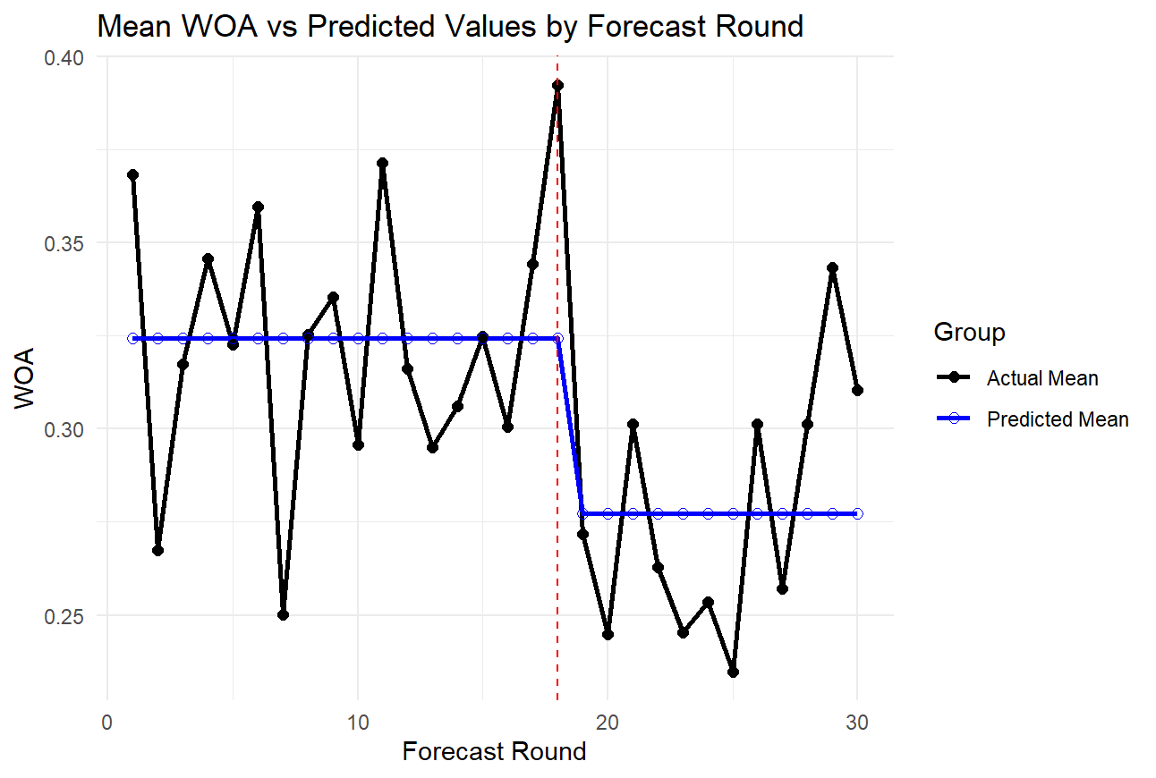
Figure 1. Mean WOA_adj and Step-Change Model Prediction across Forecast Rounds (All Participants)
Note. The red dashed vertical line marks shock onset at task round 17. The black line shows observed mean WOA_adj, and the blue line shows the fitted step-change model. Because the analysis indicator begins at task round 19, the fitted level change should not be interpreted as occurring at round 17.
Mean WOA_adj was 0.324 before the analysis breakpoint and 0.277 from task round 19 onward (delta0 = -0.047, p < .001). This indicates lower behavioral reliance after participants had observed repeated forecast errors. The shock itself occurred at round 17; accordingly, the estimate describes the fitted change beginning at round 19 rather than an immediate round-17 drop. Appendix C shows that the negative overall estimate remains under round-18 and round-17 alternatives, although its magnitude changes.
The lower post-breakpoint WOA_adj is consistent with participants reducing reliance after repeated negative performance information, as discussed in the advice-discounting literature (Yaniv & Kleinberger, 2000; Soll & Larrick, 2009). Because beliefs about reliability were not measured directly in Study 1, this mechanism remains an interpretation rather than an observed mediator.
In Model A2 (Figure 2), the AI-reference group had an estimated post-shock change of -0.058, while the Human-by-post-shock interaction was +0.023. The interaction was not statistically significant, so the numerically smaller decline under the Human Expert label does not establish different erosion across advisor types.
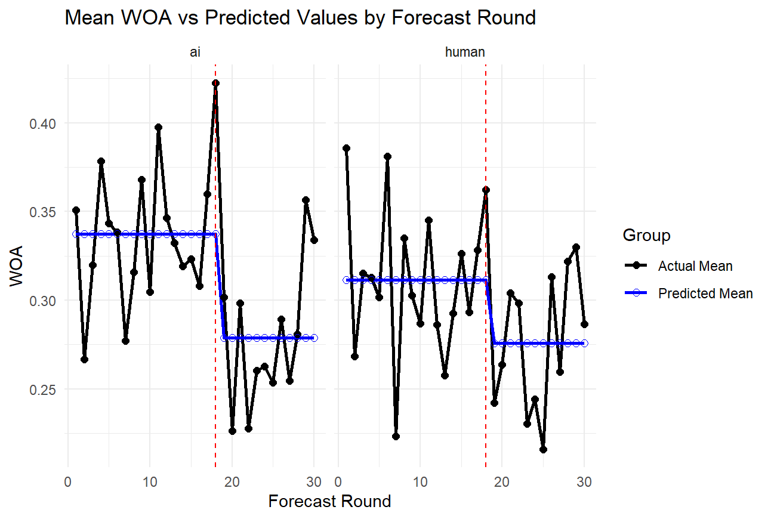
Figure 2. Mean WOA_adj and Predicted Values by Forecast Round, Separated by Advisor Type
Note. Red dashed lines mark shock onset at task round 17. Black lines show observed mean WOA_adj, and blue lines show fitted step-change values beginning at task round 19. The numerical difference between advisor labels should be interpreted with the non-significant interaction estimate.

The shock-profile analysis (Figure 3) showed a pronounced decline in the LS condition (combined post-shock change = -0.092, p < .001) and little estimated change in the AO reference condition (delta0 = -0.002, p = .911). This pattern is consistent with participants responding differently to the implemented temporary and persistent shock profiles. Because the profiles also differed in shock magnitude and cumulative exposure, the result should not be interpreted as a pure persistence effect with all other stimulus features held constant.
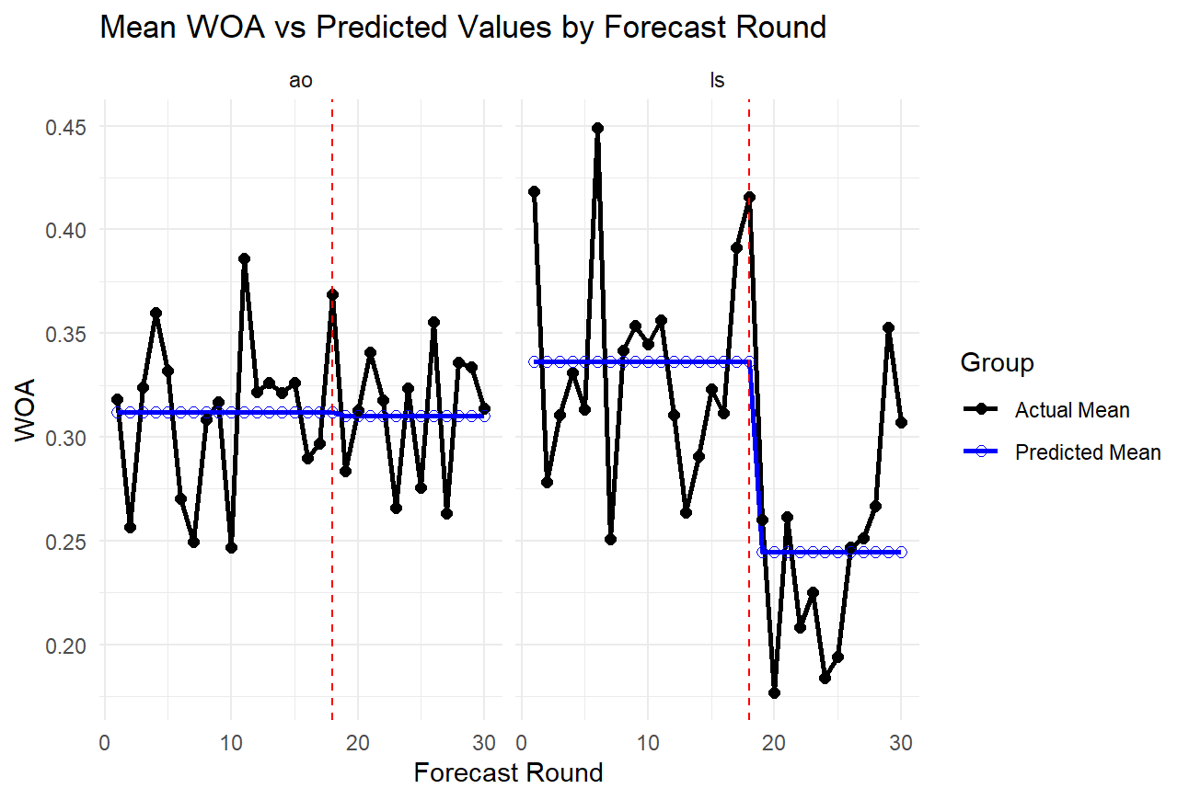
Figure 3. Mean WOA_adj and Predicted Values by Forecast Round, Separated by Shock Type
Note. The red dashed vertical lines mark shock onset at task round 17. Black lines show observed mean WOA_adj, and blue lines show fitted values from the step-change model beginning at task round 19. The LS profile shows a larger fitted post-shock reduction than the AO profile.

  - Recovery-Inclusive Model: Partial Restoration of Trust
To comprehensively examine whether and how trust recovers over time, we implemented a recovery-inclusive modeling approach incorporating two critical breakpoints: the first at Round 19 (capturing the behavioral onset of post-shock erosion, as documented in Section 3.4), and the second at Round 26 (identified through the empirical F-statistic-maximizing procedure described in Section 3.4) capturing potential recovery dynamics.
The B1 model estimated an immediate-period deviation of -0.065 (p < .001) and a recovery-period deviation from baseline of -0.022 (OLS p = .221; mixed-effects p = .097; bootstrap 95% CI [-0.060, +0.015]). Because the latter estimate is closer to zero, the point estimates are consistent with partial movement toward baseline. However, its interval includes zero, and the recovery breakpoint was selected from the Study 1 data; the result should therefore be treated as a descriptive recovery pattern requiring prospective replication.
The main recovery specification begins at task round 26, after intervention-aware advice started at round 20. This corresponds to six rounds of corrected advice (rounds 20-25) before the fitted recovery regime. Because round 26 was chosen by model-fit comparison rather than specified in advance, this delay should not be interpreted as a confirmed six-round psychological threshold. It is a descriptive feature of Study 1 that Study 2 evaluates using a prospectively fixed breakpoint.
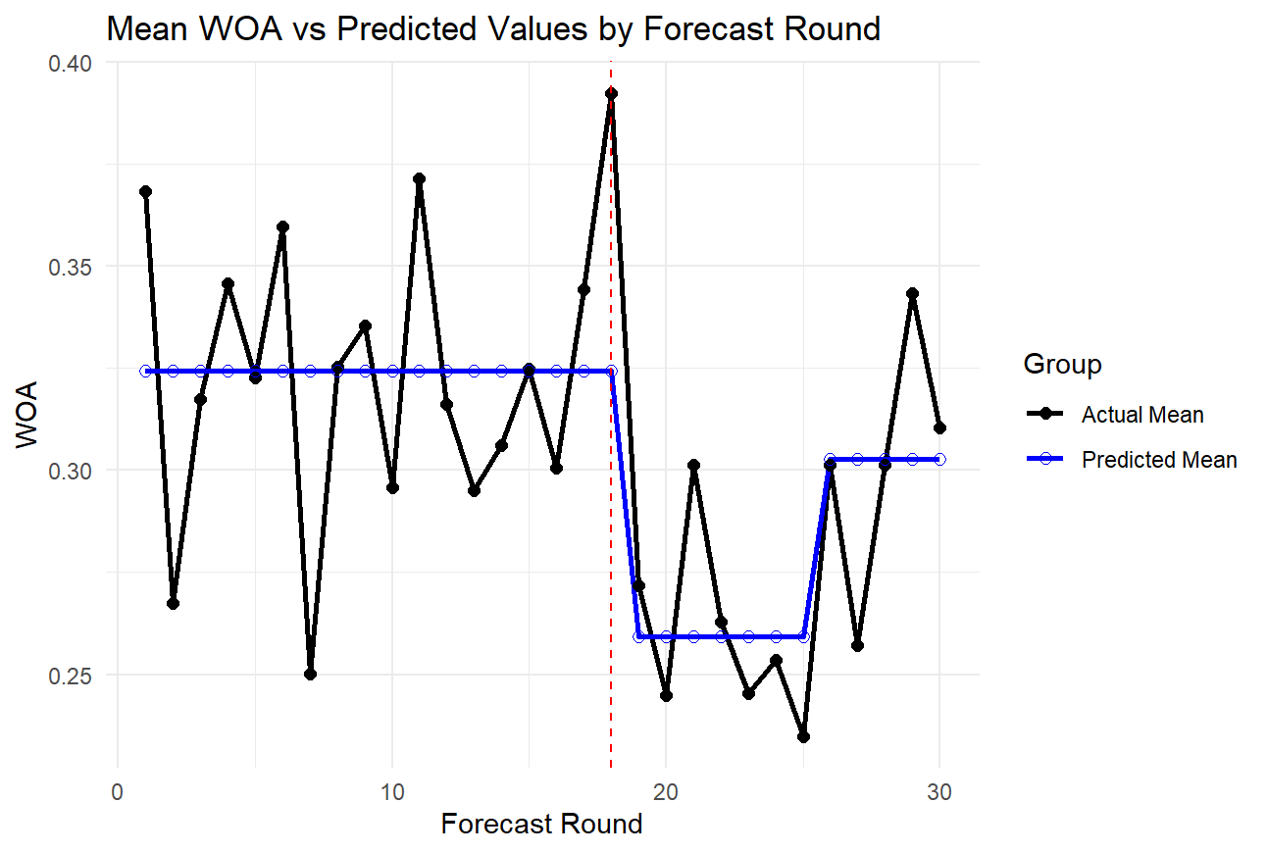
Figure 4. Mean WOA_adj and Recovery-Inclusive Model Prediction across Forecast Rounds (All Participants)
Note. The red dashed line marks shock onset at task round 17. The blue fitted values use separate erosion (rounds 19-25) and recovery (round 26 onward) regimes. The recovery-period estimate is closer to baseline but statistically imprecise and was based on a data-selected breakpoint.
In B2 (Figure 5), the AI-reference group had an erosion-period deviation of -0.076 and a recovery-period deviation from baseline of -0.034. The corresponding Human Expert deviations were -0.055 (-0.076 + 0.021) and -0.009 (-0.034 + 0.025). Neither the advisor-by-erosion interaction nor the advisor-by-recovery interaction was statistically significant; the recovery interaction was +0.025 (OLS p = .477; mixed-effects p = .335; bootstrap 95% CI [-0.061, +0.107]). The apparent advisor-label difference is therefore descriptive rather than confirmatory.
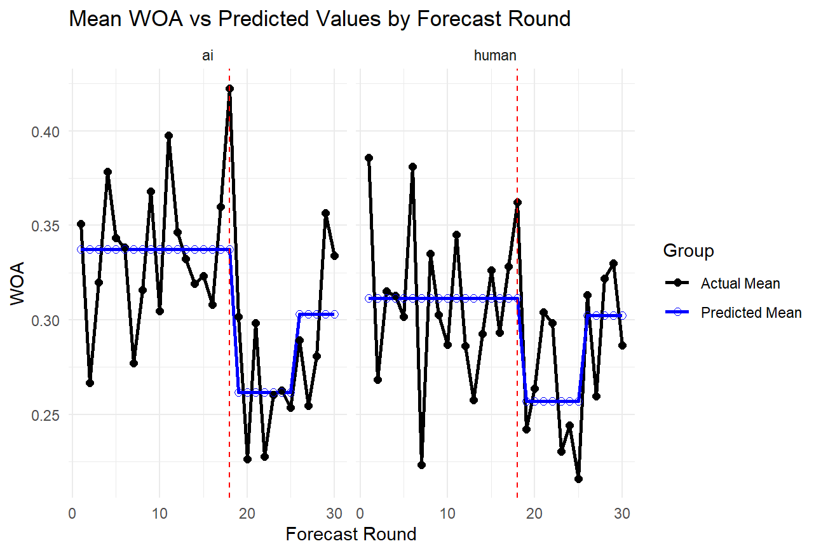
Figure 5. Mean WOA_adj and Recovery-Inclusive Model Prediction by Advisor Type (AI vs. Human Expert)
Note. Red dashed lines mark shock onset at task round 17. Black lines show observed mean WOA_adj, and blue lines show recovery-inclusive fitted values. Numerical differences between advisor labels are accompanied by non-significant interaction estimates.

In B3 (Figure 6), the LS erosion-period deviation was approximately -0.120 (-0.009 - 0.111), compared with -0.009 for AO. The LS recovery-period deviation from baseline was -0.052 (+0.008 - 0.060), compared with +0.008 for AO. The LS-by-recovery interaction (-0.060) was non-significant under OLS (p = .091), significant under mixed-effects estimation (p = .022), and had a participant-cluster bootstrap 95% CI [-0.140, +0.018]. Its magnitude also varied across recovery breakpoints. The initial LS-AO contrast is comparatively stable, whereas differential recovery remains method-sensitive and requires prospective replication.
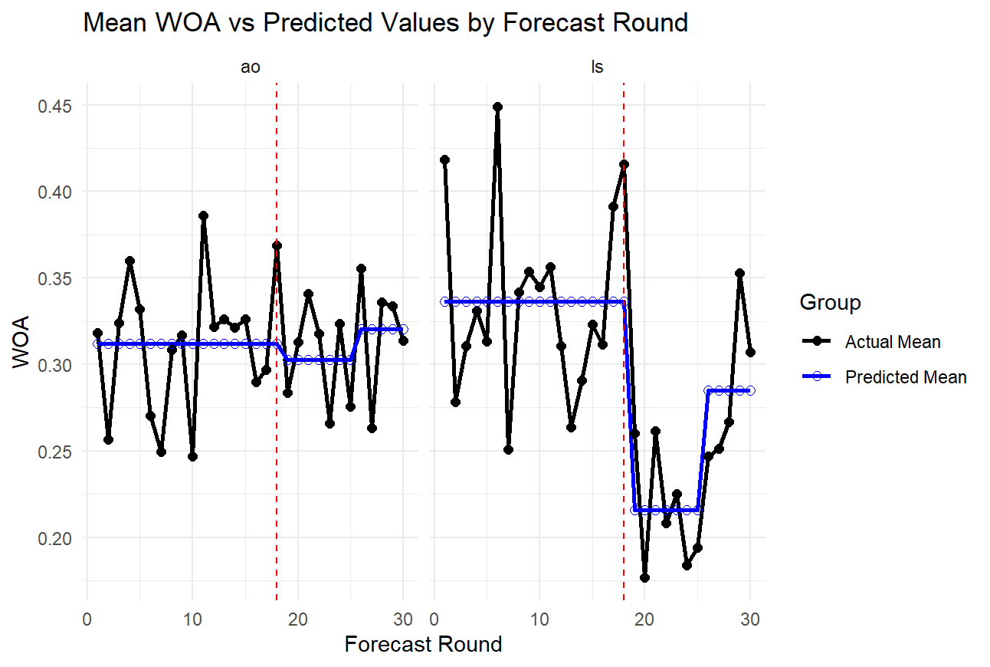
Figure 6. Mean WOA_adj and Recovery-Inclusive Model Prediction by Shock Type (AO vs. LS)
Note. Red dashed lines mark shock onset at task round 17. Black lines show observed mean WOA_adj, and blue lines show recovery-inclusive fitted values. The LS-AO erosion contrast is stable, while the differential recovery estimate is method- and breakpoint-sensitive.

4.4. Supplementary Analysis: Anchoring vs. Optimism in Forecast Adjustment
An additional question concerns the directional character of participants’ advice adjustment: did participants’ final forecasts systematically exceed the advised values, exhibiting an ‘optimism bias’ pattern of the sort discussed in judgmental forecasting research (Fildes & Goodwin, 2007; Fildes et al., 2009) and potentially relevant to stock-price predictions, where higher prices may be perceived as more desirable? To address this, we compared participants’ final forecasts to the advisors’ optimal forecasts directly across the 30 forecasting rounds.
The aggregate pattern does not support a directional optimism bias. After excluding 36 observations from six participants who entered values inconsistent with the time-series scale (initial forecasts > 100, vs. a normal range of 8–30; the full sample retained these data points in the WOA analyses reported in earlier sections, with no material effect on the conclusions), the mean Final − Advice was −0.36 across all rounds (median = 0.00; t = −2.89, p = .004), indicating that final forecasts were on average slightly below the advised values rather than above. The pattern was period-dependent: pre-shock rounds showed a modest, non-significant tendency toward optimism (mean = +0.21, p = .17), while immediate post-shock rounds (20–25) and the recovery period (26–30) showed final forecasts significantly below the advised values (means = −1.56 and −1.00, both p < .01). This pattern is consistent with participants failing to fully follow advisors’ upward revisions to the new baseline after the LS shock.
A more diagnostic analysis emerges when conditioning on the direction of the advised adjustment. When the advisor’s value was above the participant’s initial forecast (the advisor recommended an upward revision), the mean Final − Advice was −3.23 (median = −1.15), participants’ final values fell below the advised amount, anchoring partway back toward their initial estimate. When the advisor’s value was below the participant’s initial (downward recommendation), Final − Advice was +2.17 (median = +0.41), final values fell above the advised amount, again anchoring toward the initial. This bidirectional pattern is the signature of egocentric anchoring (Yaniv & Kleinberger, 2000; Soll & Larrick, 2009) rather than directional optimism bias: participants pull their forecasts toward their own initial estimate regardless of which direction the advice would move them. This finding aligns with the substantial individual heterogeneity in baseline WOA documented in Section 4.1 (ICC = 0.441) and provides a behavioral mechanism for the relatively low overall WOA observed in this and prior advice-taking studies.

- Conclusions
This study examined how behavioral reliance on AI- and Human Expert-labeled advice changed following two implemented structural-shock profiles, first in Study 1 (N = 120) and then in a preregistered Study 2 (N = 247) that fixed the analysis breakpoints in advance and added stated-trust measures. In Study 1, the LS profile produced a larger and more persistent reduction in WOA_adj than the AO profile. Advisor-label interactions were not statistically distinguishable from zero. Recovery-period point estimates were consistent with an incomplete return toward baseline, but the LS-specific recovery interaction was sensitive to estimator and breakpoint choice.
The study extends prior work by observing advice reliance across erosion and recovery periods rather than at a single post-error point. The evidence supports a robust difference between the implemented AO and LS profiles in initial erosion. Evidence about differential recovery and advisor-type moderation is more limited and is therefore treated as provisional rather than conclusive.
Taken together, the findings suggest that the temporal structure of forecasting errors warrants greater attention alongside advisor identity. In this sample, shock-profile terms predicted WOA_adj more consistently than advisor-label terms. This result is bounded by the fixed time-series realization, the bundled magnitude-persistence manipulation, the data-selected recovery breakpoint, and the absence of direct psychological-process measures in Study 1.
5.1 Theoretical Implications
This study contributes to behavioral decision research by treating advice reliance as a longitudinal trajectory and by comparing temporary and persistent shock profiles. Within the candidate models, shock-profile terms were more consistently associated with post-shock WOA_adj than advisor-label terms. This pattern qualifies advisor-identity-centered interpretations of algorithm aversion in this setting, but it does not show that advisor identity is generally irrelevant. The AI-human interactions were estimated imprecisely, and the fixed time-series paradigm may differ from cue-based tasks in which perfection-schema effects have been documented. Study 2 therefore retains the source manipulation while increasing the planned sample and prospectively testing the advisor-by-shock-by-phase interaction.
Recovery estimates are consistent with partial and asymmetric updating, but the evidentiary strength is qualified. WOA_adj fell sharply in the LS condition and later moved closer to baseline after corrected advice began. The LS-specific recovery interaction, however, was significant only under mixed-effects estimation, its cluster-bootstrap interval included zero, and its magnitude varied across recovery breakpoints. Negativity bias, loss aversion, and Slovic's trust-asymmetry principle offer plausible interpretations, but the experiment did not manipulate or directly measure those mechanisms. We therefore treat path dependence as a theoretically motivated interpretation to be tested prospectively, not as an established mechanism.
The fitted recovery regime begins at task round 26, six rounds after intervention-aware advice began at round 20. This lag is consistent with cautious updating, but because the breakpoint was selected empirically it cannot establish a fixed psychological delay. Study 2 prospectively fixes the same recovery breakpoint and includes stated-trust measurements before and after error feedback, allowing the human follow-up to test whether behavioral and stated trust move together during the proposed recovery period.
Taken together, these three contributions advance a dynamic, trajectory-based account of trust in advice-giving contexts. Rather than treating trust as a state that is either present or absent, our findings characterize it as a time-indexed process governed by the accumulation and persistence of performance signals, subject to well-documented asymmetries in human judgment. This perspective opens productive directions for future research, which we outline in the limitations section below.
5.2 Implications for the Design of Human–AI Advisory Systems
Although the primary contribution of this study is theoretical, the findings carry implications for the design of systems in which humans receive and act on algorithmic advice.
The observed asymmetry suggests that preventing sustained forecasting errors may be more effective than relying on later correction alone. Because the recovery estimates are method-sensitive, this is a design implication to be evaluated rather than a definitive cost-benefit conclusion. Systems may benefit from detecting structural change quickly and from making corrections legible before repeated errors accumulate.
The difference between the implemented AO and LS profiles also has design implications. Behavioral reliance was comparatively stable under the one-period AO profile and declined under the persistent LS profile. This pattern is consistent with users treating isolated and sustained failures differently, but causal attribution to persistence alone is limited because shock magnitude and cumulative exposure were not fully equated. The experiment also did not manipulate explanatory communication. Whether explaining why a forecast changed improves recovery is therefore a separate hypothesis for future interface research, not a conclusion of the present study.
Finally, the delayed recovery observed in our data, participants lagged several rounds behind advisors in restoring reliance, even after performance improved, points to the value of giving users active roles in the advice process. Dietvorst, Simmons, and Massey (2018) demonstrated that allowing users to modify algorithmic forecasts, even minimally, substantially reduces algorithm aversion. Our findings suggest a parallel logic for trust recovery: providing users with opportunities to engage with, adjust, or explicitly accept corrected forecasts may accelerate the cautious re-evaluation process that would otherwise unfold gradually on its own.
A related design consideration follows from the anchoring pattern documented in Section 4.4. The observation that participants pull their final forecasts toward their own initial estimates regardless of the direction of advice, a bidirectional signature of egocentric anchoring rather than optimism bias, has direct implications for the design of forecasting and recommender systems. Interfaces that require users to commit to an initial estimate before receiving advice may inadvertently reinforce anchoring on that initial value, reducing the effective weight of the advisor’s contribution regardless of its quality. Alternative interaction designs, such as presenting the advisor’s forecast first, requiring users to explicitly agree or disagree with the advice before submitting a final estimate, or providing structured elicitation of the reasoning behind any adjustment away from the advised value, may reduce anchoring on initial judgments and increase the informational value that users derive from advisory input. Empirical evaluation of these interface variations represents a promising direction for future design-oriented research.
5.3 Limitations and Directions for Future Research
Several limitations of this study point toward productive directions for future research. The most significant constraint is sample composition. Participants were recruited from MTurk and had no professional forecasting experience, which raises questions about the generalizability of the trust dynamics observed here. It is plausible that domain experts, who hold more calibrated prior beliefs about forecasting uncertainty, would respond differently to advisor errors, potentially exhibiting less severe initial erosion or more rapid recovery. Replication with professional forecasters or domain-specific populations would substantially strengthen the external validity of these findings.
A related concern is ecological and time-series-realization validity. The task used a synthetic stock-price series, researcher-set shock profiles, identical numerical forecasts across AI and Human Expert labels, and the same realized Gaussian innovation sequence for every Study 1 participant. The participant-cluster bootstrap quantifies participant-sampling uncertainty but cannot quantify uncertainty across alternative time-series realizations. Study 2 deliberately continues to hold the innovation sequence fixed while varying LS theta, which strengthens isolation of the theta-profile contrast but does not directly answer Reviewer 2's request for different noise patterns across participants. Accordingly, neither study is presented as establishing generalization across all ARIMA(0,1,1) realizations. A separate multi-realization design would require several prespecified seed sequences randomized or blocked within each profile and a model that includes realization-level variation. Natural forecasting environments also contain uncertain change detection and advisors of unequal quality, so generalization beyond the controlled setting remains open.
The study also leaves individual-difference moderators unexamined. Prior work identifies variation by domain, trust disposition, perceived expertise, and contextual framing (Castelo, Bos, & Lehmann, 2019; Glikson & Woolley, 2020; Burton, Stein, & Jensen, 2020; Hou & Jung, 2021). The present design was not specified to estimate these moderator effects. Larger targeted studies are needed to determine whether the observed shock-profile contrast and the non-significant advisor-label interactions differ across participant subgroups.
The recovery breakpoint in our models was selected empirically to maximize model fit, rather than specified a priori. While sensitivity analyses confirmed robustness across adjacent candidate rounds, Study 2 addresses this concern prospectively by fixing task round 19 as the primary post-shock breakpoint, task round 26 as the recovery-period start, and task round 18 as a prespecified robustness breakpoint before examining human outcomes.
Another limitation is that Study 1 examined one advisory relationship and one shock event. Users in practice encounter multiple advisors, repeated disruptions, and longer performance histories. Designs with repeated structural breaks and longer observation windows are needed to determine whether reliance accumulates, recalibrates, or recovers across multiple failure episodes.
A second methodological limitation concerns the operationalization of trust itself. Weight of Advice (WOA) is a behavioral (revealed-trust) measure that captures the extent to which participants adjust their forecasts toward advisor recommendations. Although WOA has been widely used and validated in advice-taking research (Bonaccio & Dalal, 2006; Yaniv & Kleinberger, 2000), it is distinct from stated-trust measures that ask participants directly to report their trust in the advisor (cf. O’Neill, 2002; Daschner & Obermaier, 2022). Prior work has documented that behavioral and stated trust can diverge, particularly when participants engage in strategic or effortful adjustment behaviors that do not fully reflect their underlying beliefs about advisor reliability. Study 2 responds by measuring baseline stated trust once and both pre-error and post-error stated trust in every round alongside WOA_adj. The resulting human data will permit direct examination of when revealed and stated trust converge or diverge.
5.4 Study 2: Design and Results
Study 2 tests whether changing the LS moving-average persistence parameter alters the erosion and recovery of behavioral reliance and stated trust while the ARIMA(0,1,1) structure and realized task noise are held constant. It was designed as a controlled extension of Study 1 and a partial response to Reviewer 2's single-series concern: it broadens the prespecified theta profiles but intentionally does not vary noise realizations across participants. In this specification, theta governs how a shock-induced forecast-error component carries into subsequent one-step-ahead forecasts. Introducing an AR term would change the adaptation mechanism rather than provide another controlled version of the same test. Study 2 therefore retains ARIMA(0,1,1), fixes seed 1001 and the innovation sequence, and varies only LS theta across prespecified profiles.
This choice reflects an identification trade-off rather than an assumption that the observed noise realization is universally representative. The focal Study 2 estimand is the effect of the prespecified theta profile under otherwise matched forecasting information. Using the same innovation sequence creates a common-noise comparison in which differences between LS-D4, LS-D8, and LS-D12 cannot be attributed to chance differences in the realized path. Fully addressing realization-level generalizability would require multiple prespecified sequences crossed with or blocked within every profile, sufficient replication within each profile-by-sequence combination, and a model that represents realization-level variation. Adding a small number of unbalanced sequences to the present eight-cell design (30 participants per cell planned) would reduce replication per sequence without cleanly identifying that additional source of variation. We therefore prioritize the controlled theta-profile contrast in Study 2, quantify participant-sampling uncertainty with participant-cluster bootstrap intervals, and limit all claims to the implemented realization; a fully crossed multi-realization experiment remains the appropriate direct test of Reviewer 2's generalizability question.
The resulting design uses eight between-subjects cells: advisor identity (AI vs. Human Expert) crossed with four approved time-series profiles (AO, LS-D4, LS-D8, and LS-D12), with a target of 30 participants per cell (planned N = 240; 247 valid completers were obtained and analyzed, Section 5.4.1). This is an incomplete-factorial profile design, not a 2 x 2 x 3 factorial. AO is represented by one profile because changing theta does not create meaningfully distinct persistence regimes for a one-period additive outlier, whereas LS is represented by three profiles because theta governs how long the error induced by a permanent level shift persists. The theta-matched AO-versus-LS-D4 comparison tests shock type while holding theta at .70, and the LS-D4/D8/D12 comparison tests whether the behavioral consequences of a level shift vary across controlled persistence regimes.
All four profiles retain the Study 1 ARIMA(0,1,1) specification (phi = 0). The AO intervention is a one-period +20 additive outlier at task round 17, whereas the LS intervention is a persistent +10 level shift beginning at task round 17. The final theta values are .70 for AO and .70, .83, and .88 for LS-D4, LS-D8, and LS-D12. D4, D8, and D12 are stimulus-construction labels based on a no-correction counterfactual: if the advisor were to continue the pre-shift forecasting rule, the residual shock-induced component after h additional rounds would decay in proportion to theta^h. The label counts the additional rounds for which this component remains above 20% of its round-17 magnitude. This diagnostic does not describe the advice actually shown for 4, 8, or 12 rounds. In every experimental condition, intervention-unaware advice is shown only in rounds 17-19 and intervention-aware optimal advice begins at round 20.
The profiles were generated with initial level 10, innovation SD 2, a 100-observation burn-in, 30 historical observations, and 30 task rounds. Seed 1001 and the complete innovation sequence are identical across all profiles. Consequently, participants are not assigned different noise realizations: condition differences arise only from advisor label, shock structure, and the approved theta value. Numerical verification showed that the LS-D4, LS-D8, and LS-D12 profiles remain above the 20% error threshold for exactly 4, 8, and 12 additional rounds, respectively, and that the displayed round-20-and-later advice matches the intervention-aware optimal forecast to numerical precision.
Table 3. Approved Study 2 profiles and the rationale for the theta manipulation
Profile | theta | Shock at task r17 | Verified counterfactual persistence | Design role
AO | .70 | +20 for one period | Not assigned; transient AO returns rapidly | Transient benchmark and theta-matched AO comparator
LS-D4 | .70 | +10 level shift | 4 additional rounds >20%; first <=20% at r22 | Theta-matched LS comparator and direct replication
LS-D8 | .83 | +10 level shift | 8 additional rounds >20%; first <=20% at r26 | Boundary-condition test of longer persistence
LS-D12 | .88 | +10 level shift | 12 additional rounds >20%; first <=20% at r30 | Boundary-condition test of still longer persistence

Study 2 also distinguishes behavioral and stated trust. Baseline stated trust is elicited once before any time-series information is shown. In each task round, participants first view the time series and submit an initial forecast; next, they view the advisor forecast and submit a final forecast together with pre-error stated trust; finally, after viewing Your forecast, Actual Value, Error, and Error Rate (%), they report post-error stated trust. WOA_adj remains the primary behavioral-trust outcome. The within-round stated-trust change (post-error minus pre-error trust) is secondary and permits a direct comparison between revealed and stated trust.
5.4.1 Participants and Procedure
Study 2 was preregistered on OSF before data collection. The registration fixed task round 19 as the primary post-shock breakpoint, task round 26 as the recovery-period start, task round 18 as a robustness breakpoint, the A- and B-series models of Section 3.4 with OLS, random-intercept mixed-effects, and participant-cluster bootstrap (B = 1,000) estimation, and two-sided Advisor x LS Persistence x Phase models for WOA_adj, pre-error stated trust, post-error stated trust, and within-round trust change. Before recruitment the complete pipeline (task application, database, export, and the locked analysis script) was exercised end to end with synthetic records; that technical check is documented in the registration and is not reported here. Data were collected on September 4, 2026 through CloudResearch Connect after Amazon Mechanical Turk announced its closure and a platform credit limit prevented publishing all eight cells there; this change, the increase of the per-cell target from 25 to 30, and the payment rule ($4.00 base plus an accuracy-ranked bonus of $0 to $2.00) are documented in a transparent-changes note filed with the registration. Participants were U.S.-based adults recruited within condition-specific projects, so cell assignment was determined by project entry rather than by within-project randomization; the eight cells were posted simultaneously.
A total of 247 participants completed all 30 task rounds and are included in the analysis (AI_AO = 31, AI_LS-D4 = 31, AI_LS-D8 = 30, AI_LS-D12 = 31, Human_AO = 30, Human_LS-D4 = 33, Human_LS-D8 = 30, Human_LS-D12 = 31). The cells slightly exceed 30 because participants who were in progress when a cell reached its target were allowed to finish. The sample was 44.1% female (M_age = 37.4, SD = 12.0, range 19-77), and 76.5% reported at least some familiarity with statistics. Median task duration was 31 minutes. In the post-task manipulation check, 234 participants (94.7%) correctly identified their assigned advisor label; as preregistered, all 247 are retained in the primary analyses and the 13 who failed the check are removed in a sensitivity analysis (Section 5.4.6). The analysis data set contains 7,410 participant-round observations; recomputing WOA_adj from the stored forecasts reproduced the database values exactly. Participants who consented but did not complete the task (n = 168, of whom 105 started the forecasting rounds) are reported in the participant-flow table deposited with the data and were compensated pro rata; they contribute no rounds to the analysis.
The procedure was identical to Study 1 except for the additions described above: baseline stated trust before any series information, pre-error stated trust submitted with each final forecast, and post-error stated trust after each round's feedback, all on 1-7 scales. Mean baseline stated trust was 3.36 (SD = 1.81) under the AI label and 3.65 (SD = 1.78) under the Human Expert label, t(245) = 1.26, p = .21. Descriptively, WOA_adj followed the Study 1 shape: high reliance in the first rounds (about .55 in rounds 1-2), a rapid decline to roughly .30 by round 4, a further dip after the round-17 shock, and a partial return afterward (Figures 7 and 8).
5.4.2 What Changed When theta Changed?
The effect of theta must be separated into the deterministic stimulus diagnostic and the behavior that participants actually experience. Under the no-correction counterfactual, theta values of .70, .83, and .88 yield exactly 4, 8, and 12 additional rounds above the 20% threshold. In the displayed task, however, all three LS profiles switch to intervention-aware optimal advice at round 20. Before that common correction, the absolute advisor error is identical at round 17 (9.59) but separates at rounds 18 and 19: 4.79 and 4.94 for LS-D4, 6.09 and 6.93 for LS-D8, and 6.59 and 7.79 for LS-D12. After correction, the profiles converge in advice accuracy; mean absolute advisor error during rounds 26-30 is 0.855 in every LS profile. Thus, the current manipulation changes the early error trajectory and its counterfactual persistence, but it does not expose participants to 4, 8, or 12 rounds of erroneous advice.
Behavioral reliance did not follow a monotonic D4-D8-D12 ordering (Figure 9; Figure 12, first panel). Mean WOA_adj in the baseline, erosion, and recovery phases was .359, .288, and .316 for LS-D4; .285, .255, and .275 for LS-D8; and .334, .259, and .322 for LS-D12. LS-D8 was therefore lowest throughout, including before the shock, whereas LS-D4 and LS-D12 were similar. In the preregistered LS-only mixed-effects model (Section 5.4.5, Table 7), relative to LS-D4, the D8-by-erosion estimate was b = +.017 (p = .62), the D12-by-erosion estimate was b = -.022 (p = .52), the D8-by-recovery estimate was b = +.043 (p = .27), and the D12-by-recovery estimate was b = -.002 (p = .97). These are the persistence-profile contrasts. By contrast, the LS-by-erosion coefficient of b = -.053 (p = .021) reported in Section 5.4.3 comes from the theta-matched AO-versus-LS-D4 analysis and is a shock-profile contrast, not evidence of a D4/D8/D12 effect.
Stated trust was likewise not ordered by profile, but it moved differently from behavioral reliance (Figure 10; Figure 12, remaining panels). Mean pre-error stated trust in the erosion phase was 3.30 for D4, 3.23 for D8, and 3.04 for D12; the recovery-phase means were 3.78, 3.64, and 3.60, all above the corresponding baseline means of 3.58, 3.61, and 3.29. Mean post-error stated trust was 3.38, 3.26, and 3.22 in erosion and 3.74, 3.61, and 3.49 in recovery, again above the baselines of 3.20, 3.18, and 3.00. Within-round trust change (post-error minus pre-error) was negative before the shock (-.39, -.43, -.29), positive during erosion (+.08, +.03, +.19), and near zero during recovery (-.03, -.03, -.11). In other words, participants in every LS profile reported restored or higher trust once corrected advice appeared, while their behavioral reliance stayed below its pre-shock level. The common round-20 correction removes between-profile differences in realized advisor accuracy throughout the recovery window, so the present design tests whether the first three post-shock error experiences carry forward into later reliance and trust; it cannot identify the effect of actually receiving 4, 8, or 12 erroneous forecasts.
5.4.3 Direct Replication of Study 1: H1 and H2 in the Theta-Matched AO versus LS-D4 Cells
The preregistered direct replication uses the four theta-matched cells (AO and LS-D4 under both advisor labels; 125 participants, 3,750 observations) and the six models of Section 3.4 with the fixed breakpoints. Table 4 reports OLS, mixed-effects, and participant-cluster bootstrap estimates; Table 5 reports fit indices. Four results parallel Study 1.
First, behavioral reliance was lower after the fixed breakpoint. In Model A1, WOA_adj fell by -.036 from task round 19 onward (OLS p = .002; mixed-effects p < .001; bootstrap 95% CI [-.061, -.012]); Figure 11 shows the fitted step for the primary and the robustness breakpoint. In the B1 model the erosion-period deviation was -.045 (p < .001 under mixed-effects estimation) and the recovery-period deviation was -.024 (mixed-effects p = .070; bootstrap CI [-.054, +.005]). As in Study 1, the recovery estimate is closer to zero than the erosion estimate but its interval includes zero, so the evidence is consistent with partial rather than complete recovery.
Second, H1 was not supported. The Human-by-post-shock interaction in A2 was +.003 (p = .91), and the Human-by-erosion and Human-by-recovery interactions in B2 were +.001 (p = .96) and +.004 (p = .89); every bootstrap interval for an advisor-label interaction included zero, and the nested likelihood-ratio test for adding the advisor interactions to B1 was not significant, chi-square(3) = 1.52, p = .68. The Human Expert label was associated with a higher baseline level of WOA_adj in the OLS specification (beta1 = +.043, p = .003) but not once participant heterogeneity was modeled (mixed-effects p = .24; bootstrap CI [-.024, +.113]). These results replicate the Study 1 null for advisor-label moderation with a fixed breakpoint and a larger sample; they do not establish that advisor identity has no effect.
Third, the shock-profile component of H2 replicated. In A3 the LS-by-post-shock interaction was -.047 (OLS p = .042; mixed-effects p = .014), and in B3 the LS-by-erosion interaction was -.053 (OLS p = .055; mixed-effects p = .021; bootstrap CI [-.113, +.005]). The AO reference-group changes were small (A3 delta0 = -.012, p = .48; B3 delta0 = -.018, p = .38). The nested test for adding the shock interactions to B1 was chi-square(3) = 7.77, p = .051. As in Study 1, the erosion contrast between the implemented AO and LS profiles is the most consistent effect, although its magnitude in Study 2 (about half the Study 1 estimate of -.111) makes the OLS and bootstrap results less decisive than the mixed-effects result.
Fourth, the LS-specific recovery interaction in B3 was -.039 (OLS p = .22; mixed-effects p = .14; bootstrap CI [-.096, +.019]), and the total LS recovery-period deviation from its pre-shock baseline was -.043 (p = .052). The LS cells therefore remained numerically below baseline after corrected advice had been shown for six or more rounds, but the differential recovery estimate is imprecise, as it was in Study 1. Table 5 shows that A3 and B3 had the lowest mixed-effects AIC values and that BIC favored the more parsimonious A1 and A3 specifications; the ICC was .31, lower than the .44 observed in Study 1.
Table 4. Study 2 Direct Replication: Regression Results for the Theta-Matched AO versus LS-D4 Cells
Model | Coef. | OLS b (SE) | Mixed-effects b (SE) | Bootstrap 95% CI
A1 | b0 | +0.328 (0.007)*** | +0.328 (0.019)*** | [+0.295, +0.363]
 | d0 | -0.036 (0.012)** | -0.036 (0.010)*** | [-0.061, -0.012]
A2 | b0 | +0.306 (0.010)*** | +0.306 (0.026)*** | [+0.258, +0.358]
 | b1 | +0.043 (0.015)** | +0.043 (0.037) | [-0.024, +0.113]
 | d0 | -0.037 (0.017)* | -0.037 (0.014)** | [-0.069, -0.007]
 | d1 | +0.003 (0.023) | +0.003 (0.019) | [-0.051, +0.051]
A3 | b0 | +0.296 (0.011)*** | +0.296 (0.026)*** | [+0.258, +0.337]
 | b1 | +0.063 (0.015)*** | +0.063 (0.037) | [-0.003, +0.134]
 | d0 | -0.012 (0.017) | -0.012 (0.014) | [-0.045, +0.019]
 | d1 | -0.047 (0.023)* | -0.047 (0.019)* | [-0.096, +0.001]
B1 | b0 | +0.328 (0.007)*** | +0.328 (0.019)*** | [+0.295, +0.363]
 | d0 | -0.045 (0.014)** | -0.045 (0.012)*** | [-0.073, -0.016]
 | g0 | -0.024 (0.016) | -0.024 (0.013) | [-0.054, +0.005]
B2 | b0 | +0.306 (0.010)*** | +0.306 (0.026)*** | [+0.258, +0.358]
 | b1 | +0.043 (0.015)** | +0.043 (0.037) | [-0.024, +0.113]
 | d0 | -0.046 (0.020)* | -0.046 (0.016)** | [-0.081, -0.009]
 | d1 | +0.001 (0.028) | +0.001 (0.023) | [-0.059, +0.056]
 | g0 | -0.026 (0.022) | -0.026 (0.019) | [-0.068, +0.017]
 | g1 | +0.004 (0.032) | +0.004 (0.026) | [-0.060, +0.070]
B3 | b0 | +0.296 (0.011)*** | +0.296 (0.026)*** | [+0.258, +0.337]
 | b1 | +0.063 (0.015)*** | +0.063 (0.037) | [-0.003, +0.134]
 | d0 | -0.018 (0.020) | -0.018 (0.017) | [-0.058, +0.023]
 | d1 | -0.053 (0.028) | -0.053 (0.023)* | [-0.113, +0.005]
 | g0 | -0.004 (0.023) | -0.004 (0.019) | [-0.044, +0.034]
 | g1 | -0.039 (0.032) | -0.039 (0.026) | [-0.096, +0.019]
Note: N = 3,750 observations from 125 participants (AI_AO 31, Human_AO 30, AI_LS-D4 31, Human_LS-D4 33) x 30 rounds. Breakpoints were preregistered: C1t = 1 for rounds 19-25 (B-series) or >= 19 (A-series); C2t = 1 for rounds >= 26. b0 = baseline level; b1 = type difference (1 = Human in A2/B2, 1 = LS in A3/B3); d0 = overall post-shock (erosion) effect; d1 = differential effect by type; g0 = overall recovery-period effect; g1 = differential recovery effect. Bootstrap intervals are percentile intervals from 1,000 participant-cluster resamples. * p < .05, ** p < .01, *** p < .001 (two-sided; stars refer to the estimator in that column).
Table 5. Study 2 Model Fit Indices (Theta-Matched AO versus LS-D4 Cells)
Model | k | F | OLS AIC | OLS BIC | ME LL | ME AIC | ME BIC | ICC
A1 | 2 | 9.60** | 2751.10 | 2769.79 | -837.54 | 1683.08 | 1708.00 | 0.313
A2 | 4 | 8.21*** | 2740.13 | 2771.28 | -836.78 | 1685.57 | 1722.95 | 0.310
A3 | 4 | 9.66*** | 2735.80 | 2766.95 | -833.77 | 1679.55 | 1716.92 | 0.310
B1 | 3 | 5.47** | 2751.76 | 2776.68 | -836.57 | 1683.14 | 1714.29 | 0.313
B2 | 6 | 5.19*** | 2742.78 | 2786.39 | -835.81 | 1687.62 | 1737.46 | 0.310
B3 | 6 | 6.09*** | 2738.31 | 2781.91 | -832.69 | 1681.37 | 1731.21 | 0.310
Note: k = number of fixed-effect parameters. F = OLS model F-statistic (** p < .01, *** p < .001). LL = log-likelihood; ME = random-intercept mixed-effects model; ICC = between-participant share of WOA_adj variance. Nested likelihood-ratio tests: B1 -> B2 (advisor interactions) chi-square(3) = 1.52, p = .68; B1 -> B3 (shock interactions) chi-square(3) = 7.77, p = .051.
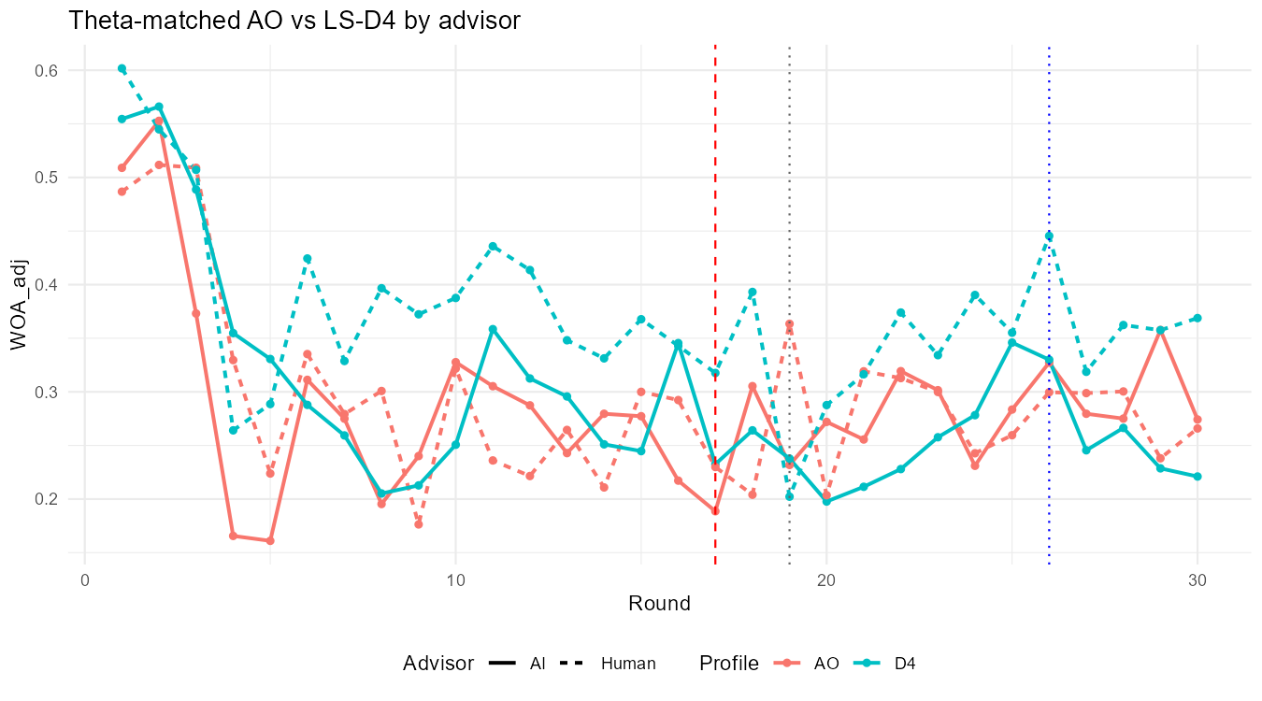
Figure 7. Study 2 mean WOA_adj by task round for the theta-matched AO and LS-D4 profiles, separated by advisor label.
Note. Solid lines show the AI label and dashed lines the Human Expert label; red marks the AO profile and teal the LS-D4 profile. The red dashed vertical line marks shock onset at task round 17, the grey dotted line the preregistered erosion breakpoint at round 19, and the blue dotted line the preregistered recovery breakpoint at round 26. Points are round means across participants in each cell (n = 30-33).
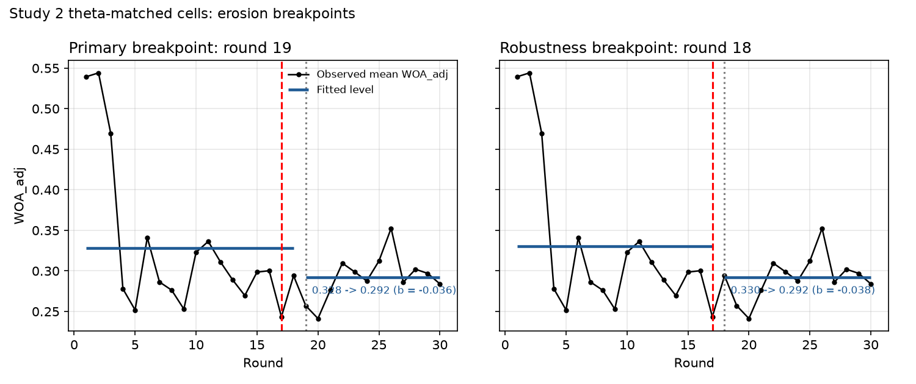
Figure 11. Study 2 prespecified primary round-19 and robustness round-18 erosion breakpoints, theta-matched cells.
Note. Black lines show observed mean WOA_adj across the 125 theta-matched participants; blue segments show the fitted pre- and post-breakpoint levels of Model A1 (round 19: .328 to .292; round 18: .330 to .292). Red dashed lines mark shock onset at round 17 and grey dotted lines the breakpoint.
5.4.4 Advisor x Shock x Phase Model
The preregistered confirmatory test of the revised H2 is the mixed-effects Advisor x Shock x Phase model in the theta-matched cells (Table 6). Neither three-way interaction was significant: Human x LS x erosion b = -.001 (p = .99) and Human x LS x recovery b = +.077 (p = .14). The only significant term was LS x recovery (b = -.078, p = .036), with LS x erosion in the same direction (b = -.053, p = .10); within the AI reference cells, the LS profile was therefore associated with lower reliance than AO after the shock, and the Human Expert cells showed the same erosion contrast with a numerically smaller recovery gap. The advisor-label main effect and the Advisor x Shock baseline interaction were not significant. In short, Study 2 does not support the prediction that the LS-versus-AO contrast is stronger under the AI label; the shock contrast appears under both labels.
Table 6. Study 2 Advisor x Shock x Phase Mixed-Effects Model for WOA_adj (Theta-Matched Cells)
Term | b | SE | p
Intercept (AI, AO, baseline) | +0.290 | 0.037 | < .001
Advisor_Human | +0.012 | 0.052 | .816
Shock_LS | +0.033 | 0.052 | .520
C1 (erosion, rounds 19-25) | -0.019 | 0.023 | .411
C2 (recovery, rounds >= 26) | +0.013 | 0.026 | .618
Advisor_Human x Shock_LS | +0.057 | 0.073 | .433
Advisor_Human x C1 | +0.003 | 0.033 | .927
Advisor_Human x C2 | -0.034 | 0.037 | .358
Shock_LS x C1 | -0.053 | 0.033 | .104
Shock_LS x C2 | -0.078 | 0.037 | .036
Advisor_Human x Shock_LS x C1 | -0.001 | 0.046 | .989
Advisor_Human x Shock_LS x C2 | +0.077 | 0.052 | .140
Note: Random-intercept model, N = 3,750 observations from 125 participants; ICC = .306. Reference categories are the AI label, the AO profile, and the pre-breakpoint baseline (rounds 1-18).
5.4.5 LS Persistence Extension and Stated Trust
The LS extension compares the three LS profiles (D4, D8, D12) under both advisor labels (186 participants, 5,580 observations) with the preregistered Advisor x Profile x Phase mixed-effects models for WOA_adj, pre-error stated trust, post-error stated trust, and within-round trust change (Table 7; Figures 8-10 and 12). For WOA_adj, only the phase main effects were significant (erosion b = -.072, p = .003; recovery b = -.065, p = .018, relative to the AI LS-D4 baseline); no profile main effect, profile-by-phase interaction, or advisor-by-profile-by-phase interaction reached significance. As Section 5.4.2 showed, the profiles do not order behavioral reliance monotonically.
Stated trust followed a different trajectory from behavioral reliance. Pre-error stated trust fell during the erosion phase (b = -.29, p < .001) and returned to baseline in the recovery phase (b = +.10, p = .30), and post-error stated trust rose above its pre-shock level during recovery (b = +.37, p = .001); within-round trust change was negative before the shock (intercept -.31), became positive during erosion (b = +.38, p < .001), and remained positive during recovery (b = +.26, p = .026). Stated trust therefore recovered more completely than behavioral reliance once corrected advice was shown, which is the revealed-versus-stated divergence anticipated in Section 5.3. A few Human x D8 x Phase interactions were significant for stated trust (post-error trust: erosion b = -.43, p = .034; recovery b = -.55, p = .016; pre-error trust: recovery b = -.40, p = .043), indicating that the Human Expert label gained less stated trust in the D8 profile than in D4. These terms were not predicted, the D8 profile also had the lowest baseline reliance, and the corresponding WOA_adj terms were not significant; we treat them as exploratory.
Because Study 2 is the first of the two studies to measure both forms of trust, we also examined how closely they track each other (exploratory, N = 247). The two stated-trust items were highly reliable across rounds (ICC(1) = .57 for pre-error and .48 for post-error trust, versus .25 for WOA_adj) and nearly interchangeable at the participant level (r = .96 between participant means). Stated and revealed trust were related but far from identical: participants who reported more trust on average also relied more on advice (participant-level r = .41 for pre-error and r = .43 for post-error trust with mean WOA_adj), and within participants, rounds with higher pre-error trust showed higher reliance (person-centered r = .34, N = 7,410 rounds), whereas post-error trust in the previous round predicted current reliance only weakly (r = .22). Baseline stated trust elicited before any series information was essentially unrelated to subsequent behavioral reliance (r = .02, p = .80) and only modestly related to in-task stated trust (r = .28). Stated and revealed trust thus share variance but respond to feedback differently, which is why the two measures diverge during recovery.
Table 7. Study 2 LS Persistence Extension: Advisor x Profile x Phase Mixed-Effects Estimates, b (p)
Term | WOA_adj | Pre-error trust | Post-error trust | Trust change
Intercept (AI, D4, baseline) | +.323 (< .001) | 3.36 (< .001) | 3.05 (< .001) | -.31 (< .001)
Advisor_Human | +.070 (.139) | +.43 (.165) | +.29 (.340) | -.14 (.132)
Profile D8 | -.023 (.640) | +.27 (.406) | +.15 (.622) | -.11 (.252)
Profile D12 | -.005 (.921) | -.32 (.321) | -.23 (.450) | +.08 (.396)
C1 (erosion) | -.072 (.003) | -.29 (< .001) | +.09 (.387) | +.38 (< .001)
C2 (recovery) | -.065 (.018) | +.10 (.296) | +.37 (.001) | +.26 (.026)
Human x D8 | -.101 (.134) | -.46 (.302) | -.33 (.448) | +.13 (.333)
Human x D12 | -.039 (.560) | +.05 (.908) | +.08 (.861) | +.02 (.859)
Human x C1 | +.002 (.944) | +.02 (.896) | +.19 (.173) | +.18 (.224)
Human x C2 | +.043 (.263) | +.17 (.228) | +.35 (.027) | +.18 (.260)
D8 x C1 | +.017 (.619) | -.06 (.640) | +.11 (.431) | +.17 (.244)
D12 x C1 | -.022 (.515) | -.01 (.925) | -.05 (.711) | -.04 (.779)
D8 x C2 | +.043 (.268) | +.04 (.762) | +.17 (.305) | +.12 (.459)
D12 x C2 | -.002 (.966) | +.16 (.256) | +.13 (.422) | -.03 (.853)
Human x D8 x C1 | +.048 (.319) | -.08 (.663) | -.43 (.034) | -.35 (.091)
Human x D12 x C1 | +.037 (.437) | +.08 (.632) | +.19 (.330) | +.11 (.589)
Human x D8 x C2 | -.019 (.734) | -.40 (.043) | -.55 (.016) | -.15 (.534)
Human x D12 x C2 | +.066 (.225) | -.07 (.738) | -.35 (.123) | -.28 (.224)
ICC | .247 | .551 | .466 | .031
Note: Random-intercept models, N = 5,580 observations from 186 participants in the six LS cells. Reference categories are the AI label, the LS-D4 profile (theta = .70), and the pre-breakpoint baseline. Stated-trust outcomes are on 1-7 scales; trust change = post-error minus pre-error trust within a round. Two-sided p-values in parentheses.
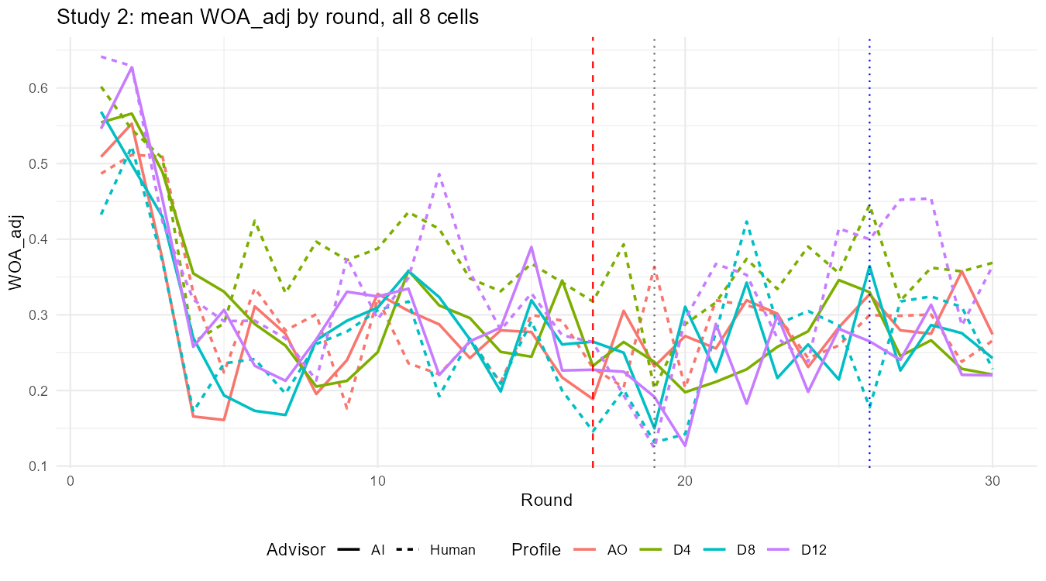
Figure 8. Study 2 mean WOA_adj by task round across all eight cells.
Note. Solid lines show the AI label and dashed lines the Human Expert label; colors distinguish the AO, LS-D4, LS-D8, and LS-D12 profiles. Vertical lines mark shock onset (round 17, red dashed), the erosion breakpoint (round 19, grey dotted), and the recovery breakpoint (round 26, blue dotted).
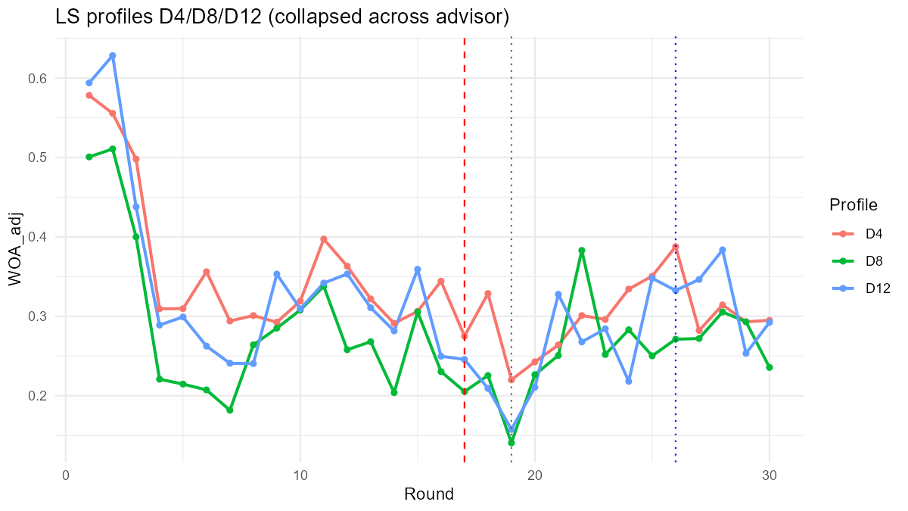
Figure 9. Study 2 mean WOA_adj by task round across LS-D4, LS-D8, and LS-D12, collapsed across advisor label.
Note. The three profiles share the same shock magnitude and the same round-20 switch to intervention-aware advice and differ only in theta (.70, .83, .88). The profiles do not order behavioral reliance monotonically.
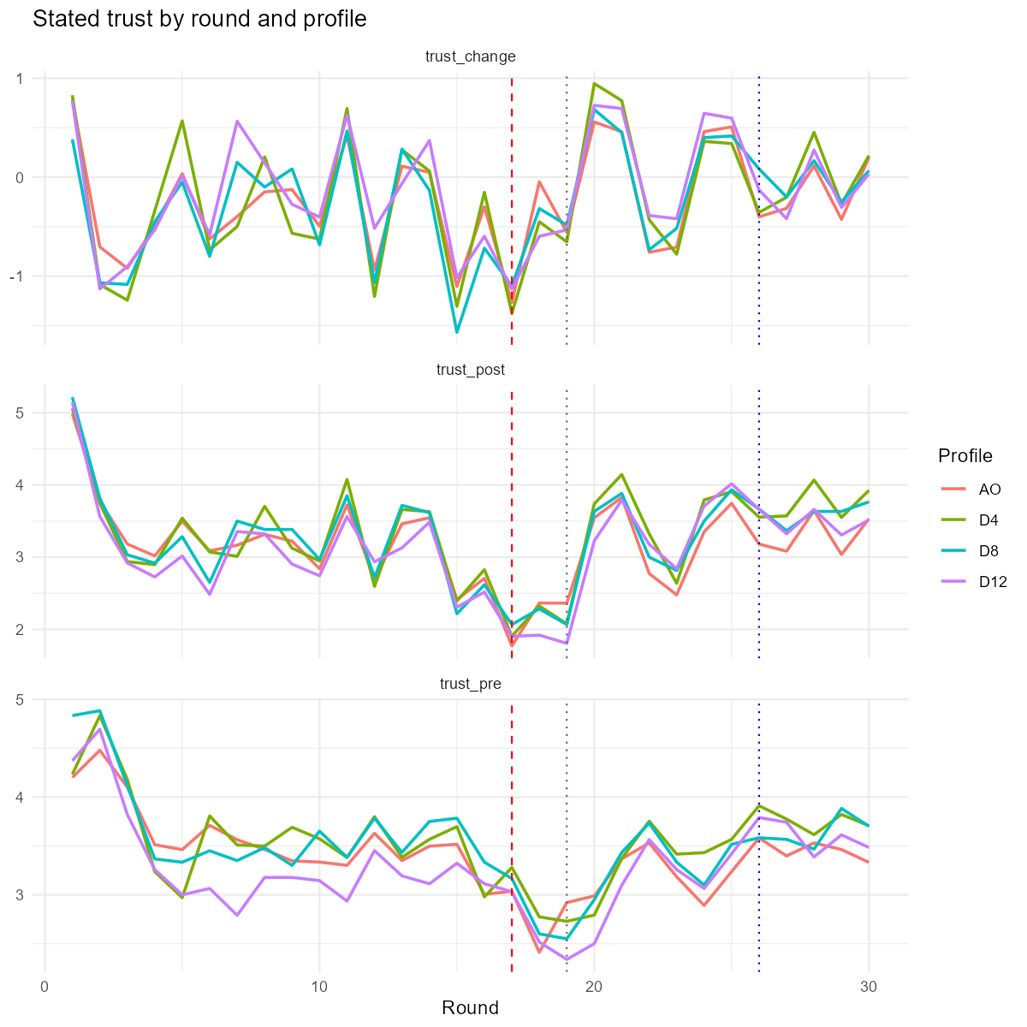
Figure 10. Study 2 stated trust by task round and profile: within-round stated-trust change after forecast error disclosure (top), post-error trust (middle), and pre-error trust (bottom).
Note. Round means across participants in each profile, collapsed across advisor label. Stated trust drops sharply at the shock and returns to or above its pre-shock level after corrected advice begins at round 20, whereas behavioral reliance (Figures 7-9) remains below baseline.
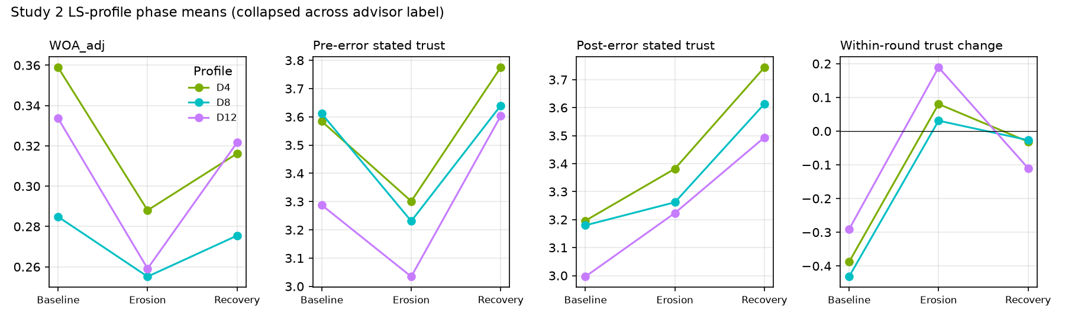
Figure 12. Study 2 LS-profile phase means for behavioral reliance, pre-error stated trust, post-error stated trust, and within-round stated-trust change.
Note. Means over the baseline (rounds 1-18), erosion (19-25), and recovery (26-30) phases for the LS-D4, LS-D8, and LS-D12 profiles, collapsed across advisor label. Behavioral reliance stays below baseline in recovery while both stated-trust measures return to or exceed baseline.
5.4.6 Robustness and Sensitivity
Three preregistered checks were run. With the erosion breakpoint moved to task round 18 (Figure 11), the A1 post-shock change was -.038 (mixed-effects p < .001), the A3 LS interaction was -.042 (p = .027), the B3 LS-by-erosion interaction was -.045 (p = .045), and every advisor-label interaction remained non-significant. With raw WOA capped at [0, 2] as the outcome, the LS baseline difference was +.071 (p < .001) and the LS-by-post-shock and LS-by-erosion interactions were -.053 (p = .077) and -.062 (p = .087), the same direction with wider uncertainty. Restricting the theta-matched sample to the 119 participants who passed the manipulation check reproduced every classification (A1 delta0 = -.039, p < .001; A3 LS x post b = -.041, p = .039; B3 LS x erosion b = -.048, p = .043; all advisor-label interactions p > .80; three-way interactions p > .22). In the overall eight-cell Advisor x Profile x Phase model (N = 247), the profile-by-phase terms were negative for every LS profile relative to AO, and significant for D12 x erosion (b = -.075, p = .026), D4 x recovery (b = -.078, p = .043), and D12 x recovery (b = -.080, p = .039); one three-way term, Human x D12 x recovery (b = +.143, p = .009), was significant and, like the Human x D8 stated-trust terms, is reported as exploratory.
5.4.7 Evaluation of Hypotheses
Table 8 summarizes the Study 2 evidence for each hypothesis alongside Study 1. H1 (greater fragility of AI trust) was not supported for behavioral reliance in either study: the advisor-by-phase interactions were near zero. The shock-type component of H2 was supported in both studies for erosion, with a smaller Study 2 effect; the differential LS recovery term was again negative but imprecise. The advisor-moderation component of H2 was not supported: the Advisor x Shock x Phase interactions were non-significant, and the shock contrast appeared under both labels. The theta extension did not yield a monotonic persistence effect on behavioral reliance, whereas stated trust recovered fully after corrected advice and behavioral reliance did not.
Table 8. Study 2 Hypothesis Evaluation Compared with Study 1
Target | Study 1 (N = 120) | Study 2 (N = 247) | Evaluation
H1: AI fragility | A2 Human x post = +.023 (n.s.); B2 Human x recovery = +.025 (n.s.) | A2 Human x post = +.003 (p = .91); B2 Human x recovery = +.004 (p = .89); LRT p = .68 | Not supported in either study
H2: LS vs. AO erosion | A3 LS x post = -.090 (p < .001); B3 LS x erosion = -.111 (p < .001) | A3 LS x post = -.047 (p = .014, ME); B3 LS x erosion = -.053 (p = .021, ME); bootstrap CI [-.113, +.005] | Supported for erosion in both; smaller in Study 2
H2: LS recovery | B3 LS x recovery = -.060 (OLS p = .091; ME p = .022) | B3 LS x recovery = -.039 (p = .14); LS total recovery deviation = -.043 (p = .052) | Directionally consistent, imprecise in both
H2: advisor moderation | Not directly tested | Human x LS x erosion = -.001 (p = .99); Human x LS x recovery = +.077 (p = .14) | Not supported
Theta extension: WOA_adj | Not tested | No profile x phase term significant; D8 lowest throughout, D4 and D12 similar | No monotonic persistence effect
Theta extension: stated trust | Not measured | Pre-error trust returned to baseline and post-error trust exceeded baseline in recovery; WOA_adj stayed below baseline | Stated and behavioral trust diverge in recovery
Note: ME = random-intercept mixed-effects estimate; LRT = nested likelihood-ratio test against B1; n.s. = not significant. All Study 2 tests used the preregistered breakpoints (rounds 19 and 26) and two-sided tests.
5.4.8 Study 2 Discussion
Study 2 strengthens the two central Study 1 findings in three ways. The post-shock erosion of behavioral reliance and the larger erosion under the persistent LS profile were reproduced with breakpoints fixed in advance, so neither depends on the data-selected breakpoint that Reviewer 1 questioned. The advisor-label null was reproduced with a sample roughly twice as large and with an explicit three-way test, which makes it less plausible that the Study 1 result reflected low power alone, although a small advisor effect still cannot be excluded. And the stated-trust measures show that participants reported restored trust after corrected advice while continuing to use that advice less than before the shock, a dissociation consistent with the distinction between revealed and stated trust raised by Reviewer 2.
Two features of the Study 2 evidence temper these conclusions. The LS-versus-AO erosion contrast was about half the Study 1 magnitude and was significant under mixed-effects estimation but not clearly under OLS or the cluster bootstrap, so its size remains uncertain. And the theta manipulation, which changed the first three post-shock forecast errors but not the number of erroneous forecasts shown, produced no ordered behavioral effect. Testing whether persistence per se matters therefore requires a design in which the correction itself is delayed for 4, 8, or 12 rounds, as noted in Section 5.4.2. Study 2 also retained the common noise realization of Study 1; the cluster-bootstrap intervals quantify participant-sampling uncertainty but not realization-level uncertainty, and a multi-realization design remains the direct test of Reviewer 2's generalizability question. Finally, Study 2 participants were recruited on CloudResearch Connect rather than MTurk and were assigned to cells by project entry; the demographic profiles of the eight cells were similar, but the recruitment change is documented as a deviation from the registration.
Data Availability
The data that support the findings of Study 1 are available from the corresponding author upon reasonable request. Study 2 participant-level and round-level data, the locked analysis script (study2_analysis.R), the full analysis log, and all result tables are available at https://aiforalab.com/p/kimwj2990/study2-dashboard/ and are deposited with the OSF registration together with the transparent-changes note describing the switch from MTurk to CloudResearch Connect and the 30-per-cell target.
Institutional Review Board Statement
Ethical review and approval were not required for this study, as it constitutes social science research that did not involve the collection of sensitive personal information from the participants. Participation in the survey was entirely voluntary, and there was no risk of psychological or emotional harm to participants.
Informed Consent Statement
Informed consent was obtained from all subjects involved in this study.
Conflict of Interest
The authors declare no conflicts of interest.
Funding
This research received no specific grant from any funding agency in the public, commercial, or not-for-profit sectors.

References
Araujo, T. B., Helberger, N., Kruikemeier, S., & de Vreese, C. H. (2020). In AI we trust? Perceptions about automated decision-making by artificial intelligence. AI & Society, 35(3), 611–623. https://doi.org/10.1007/s00146-019-00931-w
Baumeister, R. F., Bratslavsky, E., Finkenauer, C., & Vohs, K. D. (2001). Bad is stronger than good. Review of General Psychology, 5(4), 323–370. https://doi.org/10.1037/1089-2680.5.4.323
Bonaccio, S., & Dalal, R. S. (2006). Advice taking and decision-making: An integrative literature review, and implications for the organizational sciences. Organizational Behavior and Human Decision Processes, 101(2), 127–151. https://doi.org/10.1016/j.obhdp.2006.07.001
Bostrom, A., Hayes, A. L., Crosman, K. M., & Thabrew, L. (2024). Trust and trustworthy artificial intelligence: A research agenda for AI in the environmental sciences. Risk Analysis, 44(6), 1498–1513. https://doi.org/10.1111/risa.14234
Box, G. E. P., & Tiao, G. C. (1975). Intervention analysis with applications to economic and environmental problems. Journal of the American Statistical Association, 70(349), 70–79. https://doi.org/10.1080/01621459.1975.10480264
Burton, J. W., Stein, M.-K., & Jensen, T. B. (2020). A systematic review of algorithm aversion in augmented decision making. Journal of Behavioral Decision Making, 33(2), 220–239. https://doi.org/10.1002/bdm.2155
Cameron, A. C., & Miller, D. L. (2015). A practitioner’s guide to cluster-robust inference. Journal of Human Resources, 50(2), 317–372. https://doi.org/10.3368/jhr.50.2.317
Castelo, N., Bos, M. W., & Lehmann, D. R. (2019). Task-dependent algorithm aversion. Journal of Marketing Research, 56(5), 809–825. https://doi.org/10.1177/0022243719851788
Chacon, A., Kausel, E. E., & Reyes, T. (2022). A longitudinal approach for understanding algorithm use. Journal of Behavioral Decision Making, 35(4), e2275. https://doi.org/10.1002/bdm.2275
Chen, C., & Liu, L. M. (1993). Joint estimation of model parameters and outlier effects in time series. Journal of the American Statistical Association, 88(421), 284–297. https://doi.org/10.1080/01621459.1993.10594321
Daschner, S., & Obermaier, R. (2022). Algorithm aversion? On the influence of advice accuracy on trust in algorithmic advice. Journal of Decision Systems, 31(sup1), 77–97. https://doi.org/10.1080/12460125.2022.2070557
Dietvorst, B. J., & Bharti, S. (2020). People reject algorithms in uncertain decision domains because they have diminishing sensitivity to forecasting error. Psychological Science, 31(10), 1302–1314. https://doi.org/10.1177/0956797620948841
Dietvorst, B. J., Simmons, J. P., & Massey, C. (2015). Algorithm aversion: People erroneously avoid algorithms after seeing them err. Journal of Experimental Psychology: General, 144(1), 114–126. https://doi.org/10.1037/xge0000033
Dietvorst, B. J., Simmons, J. P., & Massey, C. (2018). Overcoming algorithm aversion: People will use imperfect algorithms if they can (even slightly) modify them. Management Science, 64(3), 1155–1170. https://doi.org/10.1287/mnsc.2016.2643
Dzindolet, M. T., Peterson, S. A., Pomranky, R. A., Pierce, L. G., & Beck, H. P. (2002). The role of trust in automation reliance. International Journal of Human-Computer Studies, 58(6), 697–718. https://doi.org/10.1006/ijhc.2002.1015
Faul, F., Erdfelder, E., Lang, A.-G., & Buchner, A. (2007). G*Power 3: A flexible statistical power analysis program for the social, behavioral, and biomedical sciences. Behavior Research Methods, 39(2), 175–191. https://doi.org/10.3758/BF03193146
Fildes, R., Goodwin, P., Lawrence, M., & Nikolopoulos, K. (2009). Effective forecasting and judgmental adjustments: An empirical evaluation and strategies for improvement in supply-chain planning. International Journal of Forecasting, 25(1), 3–23. https://doi.org/10.1016/j.ijforecast.2008.11.010
Fildes, R., & Goodwin, P. (2007). Against your better judgment? How organizations can improve their use of management judgment in forecasting. Interfaces, 37(6), 570–576. https://doi.org/10.1287/inte.1070.0309
Gino, F., & Moore, D. A. (2007). Effects of task difficulty on use of advice. Journal of Behavioral Decision Making, 20(1), 21-35. https://doi.org/10.1002/bdm.539
Glikson, E., & Woolley, A. W. (2020). Human trust in artificial intelligence: Review of empirical research. Academy of Management Annals, 14(2), 627–660. https://doi.org/10.5465/annals.2018.0057
Goodman, J. K., & Paolacci, G. (2017). Crowdsourcing consumer research. Journal of Consumer Research, 44(1), 196–210. https://doi.org/10.1093/jcr/ucx047
Goodwin, P., & Fildes, R. (1999). Judgmental forecasts of time series affected by special events: Does providing a statistical forecast improve accuracy? Journal of Behavioral Decision Making, 12(1), 37–53. https://doi.org/10.1002/(SICI)1099-0771(199903)12:1<37::AID-BDM319>3.0.CO;2-T
Goodwin, P., Gonul, M. S., & Önkal, D. (2013). Antecedents and effects of trust in forecasting advice. International Journal of Forecasting, 29(2), 354–366. https://doi.org/10.1016/j.ijforecast.2012.08.004
Harvey, N., & De Baets, S. (2025). Judgmental forecasting: A review of the field. International Journal of Forecasting, 41(1), 100–127. https://doi.org/10.1016/j.ijforecast.2024.06.001
Harvey, N., & Fischer, I. (1997). Taking advice: Accepting help, improving judgment, and sharing responsibility. Organizational Behavior and Human Decision Processes, 70(2), 117–133. https://doi.org/10.1006/obhd.1997.2697
Himmelstein, M. (2022). Decline, adopt or compromise? A dual hurdle model for advice utilization. Judgment and Decision Making, 17(2), 384–415. https://doi.org/10.1017/S1930297500009281
Hou, Y., & Jung, M. (2021). Who is the expert? Reconciling algorithm aversion and algorithm appreciation in AI-supported decision making. Proceedings of the ACM on Human-Computer Interaction, 5(CSCW1), Article 71. https://doi.org/10.1145/3449193
Hyndman, R. J., & Athanasopoulos, G. (2018). Forecasting: Principles and practice (2nd ed.). OTexts. https://otexts.com/fpp2/
Kahneman, D., & Tversky, A. (1979). Prospect theory: An analysis of decision under risk. Econometrica, 47(2), 263–291. https://doi.org/10.2307/1914185
Kahr, P. K., Rooks, G., Willemsen, M. C., & Snijders, C. C. P. (2024). Understanding trust and reliance development in AI advice: Why the initial phase matters. International Journal of Human–Computer Interaction, 40(21), 6819–6838. https://doi.org/10.1080/10447318.2023.2261606
Lim, J. S., & O'Connor, M. (1995). Judgmental adjustment of initial forecasts: Its effectiveness and biases. Journal of Behavioral Decision Making, 8(3), 149–168. https://doi.org/10.1002/bdm.3960080302
Logg, J. M., Minson, J. A., & Moore, D. A. (2019). Algorithm appreciation: People prefer algorithmic to human judgment. Organizational Behavior and Human Decision Processes, 151, 90–103. https://doi.org/10.1016/j.obhdp.2018.12.005
Longoni, C., Bonezzi, A., & Morewedge, C. K. (2019). Resistance to medical artificial intelligence. Journal of Consumer Research, 46(4), 629-650. https://doi.org/10.1093/jcr/ucz013
Madhavan, P., & Wiegmann, D. A. (2007). Similarities and differences between human-human and human-automation trust: An integrative review. Theoretical Issues in Ergonomics Science, 8(4), 277–301. https://doi.org/10.1080/14639220500342768
O’Neill, O. (2002). A question of trust: The BBC Reith Lectures 2002. Cambridge University Press.
Önkal, D., Goodwin, P., Thomson, M., Gönül, S., & Pollock, A. (2009). The relative influence of advice from human experts and statistical methods on forecast adjustments. Journal of Behavioral Decision Making, 22(4), 390–409. https://doi.org/10.1002/bdm.637
Prahl, A., & Van Swol, L. (2017). Understanding algorithm aversion: When is advice from automation discounted? Journal of Forecasting, 36(6), 691–702. https://doi.org/10.1002/for.2464
Raftery, A. E. (1995). Bayesian model selection in social research. Sociological Methodology, 25, 111–163. https://doi.org/10.2307/271063
Rebholz, T. R. (2026). Lay beliefs about artificial versus artificial intelligence: Rethinking Theory of Machine. Collabra: Psychology, 12(1), Article 155671. https://doi.org/10.1525/collabra.155671
Rebholz, T. R., Biella, M., & Hütter, M. (2024). Mixed-effects models for behavioral advice-taking research: A tutorial. Behavior Research Methods, 56(4), 3948–3971. https://doi.org/10.3758/s13428-023-02216-z
Rebholz, T. R., Koop, A., & Hütter, M. (2024). Conversational user interfaces: Explanations and interactivity positively influence advice taking from generative artificial intelligence. Technology, Mind, and Behavior, 5(4), 208–218. https://doi.org/10.1037/tmb0000136
Rozin, P., & Royzman, E. B. (2001). Negativity bias, negativity dominance, and contagion. Personality and Social Psychology Review, 5(4), 296–320. https://doi.org/10.1207/S15327957PSPR0504_2
Shin, D. (2021). The effects of explainability and causability on perception, trust, and acceptance: Implications for explainable AI. International Journal of Human-Computer Studies, 146, Article 102551. https://doi.org/10.1016/j.ijhcs.2020.102551
Slovic, P. (1993). Perceived risk, trust, and democracy. Risk Analysis, 13(6), 675–682. https://doi.org/10.1111/j.1539-6924.1993.tb01329.x
Soll, J. B., & Larrick, R. P. (2009). Strategies for revising judgment: How (and how well) people use others' opinions. Journal of Experimental Psychology: Learning, Memory, and Cognition, 35(3), 780–805. https://doi.org/10.1037/a0015145
Tsay, R. S. (1988). Outliers, level shifts, and variance changes in time series. Journal of Forecasting, 7(1), 1–20. https://doi.org/10.1002/for.3980070102
Tversky, A., & Kahneman, D. (1991). Loss aversion in riskless choice: A reference-dependent model. The Quarterly Journal of Economics, 106(4), 1039–1061. https://doi.org/10.2307/2937956
Yaniv, I. (2004). Receiving other people's advice: Influence and benefit. Organizational Behavior and Human Decision Processes, 93(1), 1-13. https://doi.org/10.1016/j.obhdp.2003.08.002
Yaniv, I., & Kleinberger, E. (2000). Advice taking in decision making: Egocentric discounting and reputation formation. Organizational Behavior and Human Decision Processes, 83(2), 260–281. https://doi.org/10.1006/obhd.2000.2909

Appendix A: Screenshots of Study 1 Experimental Interface
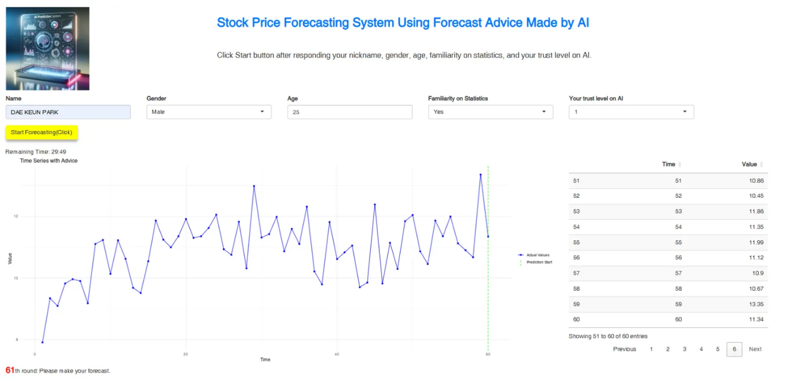
Figure A1. Study 1 AI-labeled initial experimental setup interface. Participants enter demographic information including name, gender, age, familiarity with statistics, and initial trust level in AI before beginning the forecasting task.
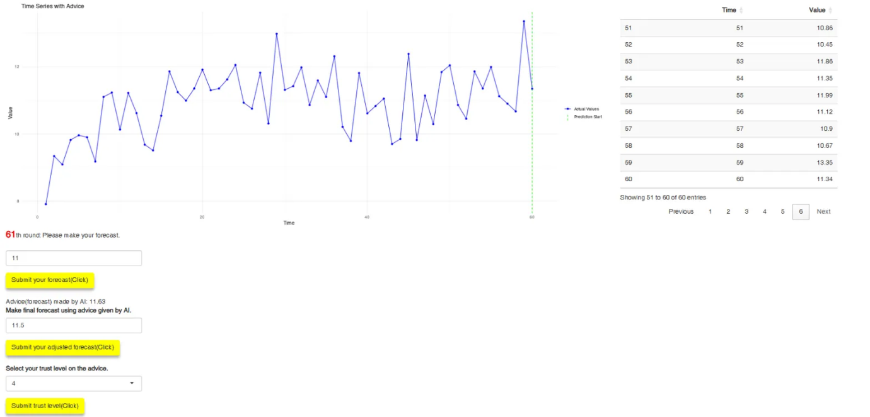
Figure A2. Study 1 AI-labeled prediction and advice incorporation interface. Participants observe the time series chart, make initial forecasts, receive advisor recommendations, and submit adjusted predictions. The interface displays both the historical data and advisor's forecast value.
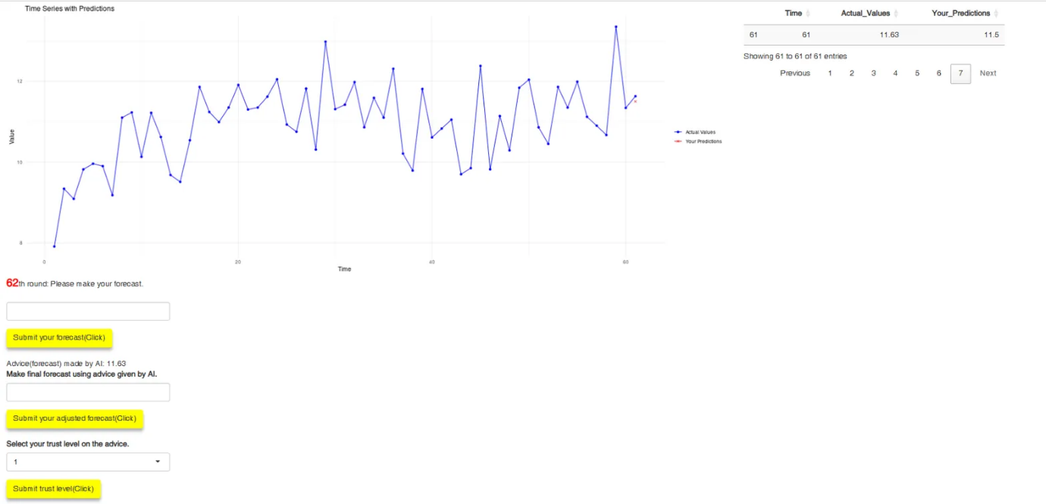
Figure A3. Study 1 AI-labeled feedback and progression interface. After submitting their prediction, participants see the actual value, their prediction, and prediction error before proceeding to the next forecasting round.

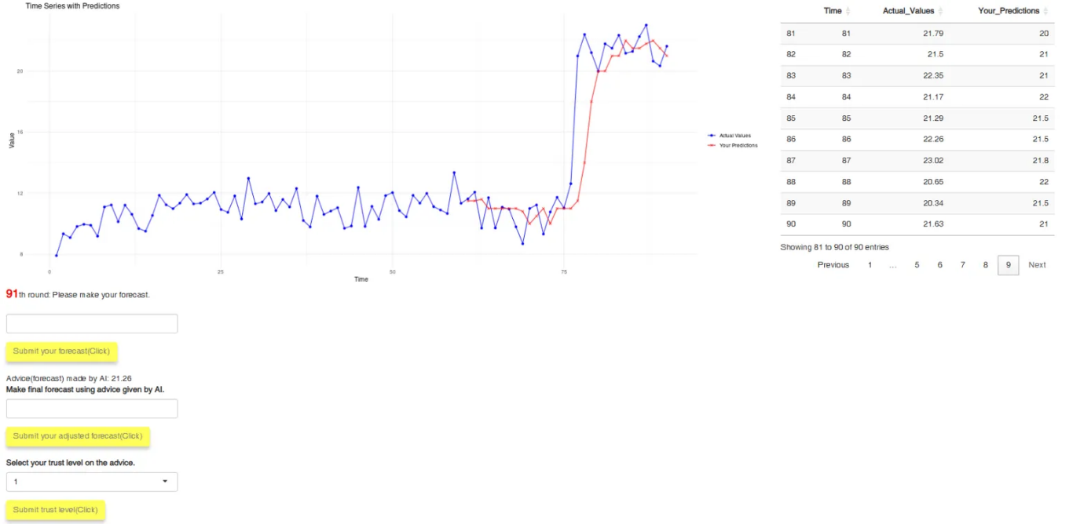
Figure A4. Study 1 AI-labeled post-shock interface. The LS begins at global time point 77 (task round 17), after which the displayed series moves to a higher level.

Appendix B. Recovery Breakpoint Sensitivity
Table B1. B-series Model Coefficients across Candidate Recovery Breakpoints
Model | Coef. | t₂ = 22 | t₂ = 23 | t₂ = 24 | t₂ = 25 | t₂ = 26 ★ | t₂ = 27
B1 | δ₀ | -0.052* | -0.054** | -0.059** | -0.061*** | -0.065*** | -0.060***
 | γ₀ | -0.045* | -0.043* | -0.038* | -0.033* | -0.022 | -0.021
 | F | 6.52 | 6.60 | 6.99 | 7.45 | 8.73 | 8.10
B2 | δ₀ | -0.062* | -0.074** | -0.074** | -0.074** | -0.076*** | -0.072***
 | δ₁ | +0.021 | +0.040 | +0.031 | +0.027 | +0.021 | +0.025
 | γ₀ | -0.057** | -0.051* | -0.047* | -0.042† | -0.034 | -0.031
 | γ₁ | +0.024 | +0.015 | +0.017 | +0.019 | +0.025 | +0.019
 | F | 3.11 | 3.21 | 3.32 | 3.49 | 4.00 | 3.75
B3 | δ₀ | +0.000 | +0.002 | -0.008 | -0.005 | -0.009 | -0.003
 | δ₁ | -0.104* | -0.111** | -0.102** | -0.112*** | -0.111*** | -0.114***
 | γ₀ | -0.003 | -0.004 | +0.002 | +0.001 | +0.008 | -0.001
 | γ₁ | -0.085** | -0.079** | -0.081** | -0.067* | -0.060† | -0.041
 | F | 5.19 | 5.31 | 5.40 | 5.78 | 6.37 | 6.38

Note: ★ marks the empirically optimal breakpoint reported as the main specification in Section 4.3. Yellow shading highlights the main column. Significance markers: † p < .10, * p < .05, ** p < .01, *** p < .001.

Appendix C. Post-shock Dummy Robustness
Table C1. Coefficient Estimates Across Post-shock Breakpoint Specifications
Model | Coef. | Row ≥ 19 (main, ★) | Row ≥ 18 | Row ≥ 17 (shock)
A1 | δ₀ | -0.047*** | -0.034** | -0.029*
A2 | δ₀ | -0.058** | -0.042* | -0.036*
 | δ₁ | +0.023 | +0.017 | +0.014
A3 | δ₀ | -0.002 | +0.006 | +0.004
 | δ₁ | -0.090*** | -0.080** | -0.065*
B1 | δ₀ | -0.065*** | -0.044** | +0.017
 | γ₀ | -0.022 | -0.018 | -0.041**
B2 | δ₀ | -0.076*** | -0.051* | +0.031
 | δ₁ | +0.021 | +0.012 | -0.027
 | γ₀ | -0.034 | -0.029 | -0.054**
 | γ₁ | +0.025 | +0.023 | +0.026
B3 | δ₀ | -0.009 | +0.002 | +0.007
 | δ₁ | -0.111*** | -0.093** | +0.021
 | γ₀ | +0.008 | +0.011 | +0.003
 | γ₁ | -0.060† | -0.058 | -0.088**
 | t₂ | 26 | 26 | 20

Note: ★ marks the main specification reported in Section 4.3. The bottom row shows the empirically optimal recovery breakpoint t₂ identified separately for each c₁ specification (search window 22–27 for Row ≥ 18 and 19; window 20–27 for Row ≥ 17). Significance markers: † p < .10, * p < .05, ** p < .01, *** p < .001.

